

Bachelor of Computer Applications (BCA) Programme

Project Report

BCA Sem VI

AY 2023-24

*Project Title: EVENT ORGANISER*

***By***

|  |  |
| --- | --- |
| Exam No | Name of Student |
| 6171 | PATEL DHRUV RAJESHBHAI. |
| 6169 | PATEL DEV SHAILESHBHAI. |
| 6182 | PATEL KENIL THAKORBHAI. |
| 6331 | SONI ANANT RAJESHKUMAR. |

|  |  |
| --- | --- |
| Project Guide by : | |
| Prof. Khushboo D patel. |  |



[Certificate will be given by college]

C E R T I F I C A T E

This is to certify that

Ms./Mr.________________________________________________________examination number ______________ has satisfactorily completed his/her project work entitled ____________________________________________ as partial fulfillment of requirements for BCA Sem VI, during the academic year 2023-24.

|  |  |
| --- | --- |
| Date: |  |
| Place: Surat | Prof. Khushboo D Patel.  SDJ International College,  Surat |

**Acknowledgement**

The success and outcome of this project required a lot of guidance and assistance from many people, and we are extremely fortunate to have gotten this all along with the completion of our project work. Whatever we have done is only due to such guidance and assistance.

We would not forget to thank I/C Principal Dr. Aditi Bhatt, IQAC coordinator and trust representative Dr. Vaibhav Desai, Head of BCA Department Dr. Vimal Vaiwala and Project guide ***Prof. Khushboo D Patel*** and all other assistant professors, who took a keen interest in our project work and guided us all along till the completion of our project work by providing all the necessary information for developing a good system.

We are extremely grateful to him/herfor providing such nice support and guidance, thoughhe/she had a busy schedule managing the college dealings.

We are thankful and fortunate enough to have gotten support and guidance from all the teaching staff in the Bachelor of Computer Application Department, which helped us successfully complete our project work. Also, we would like to extend our sincere regards to all the non-teaching staff of the Bachelor of Computer Application Department for their timely support.

Patel Dhruv Rajeshbhai. (6171)

Patel Dev Shaileshbhai. (6169)

Patel Kenil Thakorbhai. (6182)

Soni Anant Rajeshkumar. (6331)

I N D E X

|  |  |  |
| --- | --- | --- |
| **Sr. No** | **Description** | **Page No.** |
| 1 | Introduction | 1 |
|  | 1.1 Project description | 2 |
|  | 1.2 Project Profile | 3 |
| 2 | Environment Description | 4 |
|  | 2.1 Hardware and Software Requirements | 5 |
|  | 2.2 Technologies Used | 6 |
| 3 | System Analysis and Planning | 10 |
|  | 3.1 Existing System and its Drawbacks | 11 |
|  | 3.2 Feasibility Study | 14 |
|  | 3.3 Requirement Gathering and Analysis | 16 |
| 4 | Proposed System | 18 |
|  | 4.1 Scope | 19 |
|  | 4.2 Project modules & functionalities Constraints | 21 |
| 5 | Detail Planning | 24 |
|  | 5.1 Data Flow Diagram / UML | 25 |
|  | 5.2 Process Specification / Activity Flow Diagram | 30 |
|  | 5.3 Data Dictionary | 33 |
|  | 5.4 Entity-Relationship Diagram / Class Diagram | 34 |
| 6 | System Design | 35 |
|  | 6.1 Database Design | 36 |
|  | 6.2 Directory Structure | 42 |
|  | 6.3 Input Design | 45 |
|  | 6.4 Output Design | 65 |
| 7 | Software Testing | 68 |
|  | 7.1 Unit Testing | 73 |
|  | 7.2 Integration Testing | 77 |
|  | 7.3 System Testing | 79 |
| 8 | Limitations and Future Scope of Enhancements | 80 |
| 9 | Bibliography & Reference | 85 |

**1. Introduction**

**1.1 Project description**

Our event organizers' website is a comprehensive platform designed to streamline the process of planning and executing events of any scale. With a user-friendly interface, it offers an array of features including event creation tools, venue selection assistance, vendor management systems, attendee registration and ticketing solutions, and customizable event websites. Through seamless integration with social media platforms, our website maximizes event exposure and engagement. Additionally, robust analytics tools provide organizers with valuable insights into attendee demographics and event performance, enabling informed decision-making for future events. Whether it's a corporate conference, wedding, or community gathering, our platform empowers organizers to create unforgettable experiences with ease and efficiency.

event organizers' website entails numerous intricate features and functionalities aimed at simplifying the process of event planning and management. Our platform is meticulously designed to cater to the diverse needs of event organizers, regardless of the event's scale or complexity. With a sleek and intuitive user interface, users can effortlessly navigate through the various tools and resources available to them. From event creation to execution, our website offers a comprehensive suite of services to ensure every aspect of the event is meticulously organized and executed flawlessly.

One of the key features of our website is its event creation tools, which allow organizers to set up and customize their events according to their specific requirements. Whether it's a corporate conference, a wedding, a music festival, or a charity fundraiser, our platform accommodates all types of events. Organizers can input essential details such as event name, date, time, location, and description, providing attendees with comprehensive information about the event.

Moreover, our website offers assistance in venue selection, helping organizers find the perfect location that suits their event's needs and budget. With a vast database of venues ranging from conference centers and hotels to outdoor spaces and banquet halls, organizers can easily browse and compare different options before making a decision. Additionally, our platform provides valuable insights into each venue, including amenities, capacity, accessibility, and reviews from past users, enabling organizers to make informed choices.

**1.2 Project Profile**

|  |  |
| --- | --- |
| **Definition** : | Event Organisers will provides the platform for book any events in any place and any city or state. |
| **Developed For :** | SDJ International College, Vesu, Surat |
| **Project Guide(s):** | Prof. Khushboo D Patel |
| **Front End:** | PHP |
| **Scripting language :** | PHP, CSS, BOOTSTRAP, JAVASCRIPT |
| **Back End :** | Xampp Server |
| **Operating System:** | Microsoft Windows 11 |
| **Tools used for ERD & DFD** | Sublime Text, Visual Studio, Xampp , Chrome |
| **Submitted By** | Patel Dhruv R. (6171)  Patel Dev S. (6169)  Patel Kenil T. (6182)  Soni Anant R. (6331) |

**2. Environment Description**

**2.1 Hardware and Software Requirements**

Event Organizers requires following technical specifications to run properly and efficiently.

* **Hardware Requirement:**
* Intel® Core™ i5- 1115G4 CPU @ 3.00GHz 2.90 GHz
* Web Browser (For Testing)
* Minimum 8.0 GB DDR3 RAM
* 64-bit Operating System
* 512 GB Hard Disk Drive
* **Software Requirement:**
* Windows 11
* MySQL
* XAMPP Server
* Bootstrap, CSS, JavaScript
* Browsers: Google Chrome

**2.2 Technologies Used**

**Front End:**

• **HTML:**

HTML, standing for Hypertext Markup Language, forms the backbone of the World Wide Web. It's a markup language that enables users to craft documents comprising text, images, links, and multimedia elements. The core purpose of HTML lies in structuring web content through a system of tags and attributes. These tags define the elements of a webpage, from headings and paragraphs to images and hyperlinks. Without HTML, the internet as we know it would lack the cohesive structure that enables seamless navigation and interaction. With the constant evolution of technology, HTML has progressed through multiple versions, each iteration introducing advancements to enrich the browsing experience. From HTML 2.0 to the latest HTML5 standard, the language has expanded its capabilities to accommodate modern web development practices. HTML documents are interpreted by web browsers, which parse the code and render it visually on users' screens. This visual representation allows users to consume content, interact with web applications, and navigate through interconnected pages effortlessly. As the foundation of web development, HTML serves as a prerequisite skill for anyone venturing into the field of web design or programming. Its simplicity and versatility make it accessible to beginners while offering advanced features for seasoned developers. HTML's semantic structure promotes accessibility and search engine optimization, ensuring that content is both easily discoverable and comprehensible to users and search engines alike.

• **CSS**:

CSS, or Cascading Style Sheets, is a fundamental component in web development, serving as a style sheet language that defines the presentation of documents crafted in markup languages such as HTML and XHTML. It enables developers to establish the visual aesthetics and layout of web pages and user interfaces, contributing significantly to the overall user experience. Beyond its conventional use in HTML and XHTML, CSS can be applied to various XML-based documents like SVG and XUL, extending its versatility across different media platforms including speech rendering.In the realm of web development, CSS stands alongside HTML and JavaScript as one of the primary technologies utilized to design visually captivating webpages and user interfaces. Its role is pivotal in creating engaging interfaces for web applications and extends its influence to numerous mobile applications as well. Prior to the advent of CSS, the presentation attributes of HTML documents were intricately entwined within the markup itself. This entailed repetitive declarations of font colors, background styles, element alignments, borders, and sizes directly within the HTML codebase.However, the introduction of CSS revolutionized this approach by allowing developers to externalize such presentational information into separate style sheets. By doing so, CSS significantly streamlines the HTML markup, resulting in cleaner and more maintainable codebases. This separation of concerns facilitates easier management of styling across multiple webpages, enhancing scalability and consistency within web projects. Furthermore, CSS embraces the concept of cascading, enabling developers to establish hierarchical precedence among style rules, thereby empowering fine-grained control over the visual presentation of elements.

**Back End:**

**MySQL:**

MySQL is a versatile relational database management system known for its compatibility with various platforms, including Linux, UNIX, and Windows. It finds extensive utilization in diverse applications, with a significant presence in web-based applications and online publishing realms. A cornerstone of many open-source enterprise stacks, MySQL often features prominently in LAMP setups, which combine Linux, Apache, MySQL, and PHP to form a robust web development platform. This integration with LAMP makes MySQL a pivotal component in the arsenal of developers working on PHP-based projects. For instance, PHPBB, a popular open-source forum software, exemplifies the seamless synergy between PHP and MySQL, showcasing their effectiveness in powering dynamic web applications. MySQL's adaptability and reliability make it a preferred choice for developers seeking a scalable and efficient database solution. Its support for ACID (Atomicity, Consistency, Isolation, Durability) properties ensures data integrity and transactional consistency, bolstering its appeal for mission-critical applications. Moreover, MySQL's performance optimizations, such as indexing and query caching, contribute to its reputation for delivering high-speed data retrieval and processing capabilities. Its community edition offers a cost-effective option for businesses and developers looking to harness the power of an enterprise-grade database system without hefty licensing fees. Additionally, MySQL's comprehensive documentation and active user community foster a supportive environment for troubleshooting and knowledge sharing, facilitating smoother development and maintenance workflows.

**XAMPP:**

XAMPP, an acronym for Cross-Platform (X), Apache (A), MySQL (M), PHP (P), and Perl (P), is a versatile and lightweight Apache distribution crafted to facilitate the effortless setup of a local web server tailored for testing purposes. Offering a comprehensive package, XAMPP encompasses all the essential components required to establish a robust web server environment, including the server application (Apache), the database system (MySQL), and the scripting language (PHP), all neatly packaged within a single, easily extractable file. Its cross-platform compatibility ensures seamless operation across Linux, Mac, and Windows operating systems, catering to a diverse user base.

Similar to the configurations utilized in most real-world web server deployments, XAMPP streamlines the transition from a local testing environment to a live server, simplifying the migration process for developers. At its core, XAMPP comprises four primary components, with Apache serving as the pivotal web server application responsible for processing and delivering web content to end-users. Renowned for its reliability and efficiency, Apache holds the distinction of being the most widely utilized web server globally, powering an impressive 54% of all websites on the internet.

**PHP:**

PHP stands for Hypertext Preprocessor. It is a server-side scripting language that powers some of the most popular websites in the world, including WordPress and Facebook. It is open source, relatively easy to learn, and works perfectly with MySQL, making it a popular choice for web developers. A cornerstone of web development, PHP offers a rich set of features and functionalities, facilitating the creation of dynamic and interactive web pages. Its open-source nature encourages collaboration and innovation within the development community, leading to continuous improvements and updates. With PHP, developers can build robust web applications with ease, leveraging its extensive documentation and vast array of libraries and frameworks. Renowned for its performance and scalability, PHP empowers developers to craft responsive and efficient web solutions that cater to diverse user needs. Its seamless integration with HTML allows for the creation of dynamic web content, enabling businesses to deliver engaging online experiences to their audiences. From e-commerce websites to content management systems, PHP provides the backbone for countless online ventures, driving innovation and growth in the digital landscape.

**Bootstrap**:

Bootstrap is a versatile tool used by developers worldwide to enhance the design and functionality of websites and web applications. It streamlines the process of creating dynamic interfaces by offering a wide range of pre-designed components and layouts. From typography to forms, buttons to navigation menus, Bootstrap provides HTML- and CSS-based templates that ensure consistency and responsiveness across various devices and screen sizes. With its optional JavaScript extensions, Bootstrap enables developers to add interactive elements seamlessly. By simplifying the development process, Bootstrap empowers developers to focus more on enhancing user experience and less on coding from scratch. Its robust set of stylesheets ensures a modern and uniform appearance for text, tables, and form elements, contributing to a polished and professional look. As a front-end web framework, Bootstrap primarily caters to the user interface, complementing server-side code residing on the back end. This clear separation of concerns allows developers to efficiently manage both front-end and back-end aspects of web development. Whether you're a seasoned developer or just starting, Bootstrap offers a user-friendly platform to create visually appealing and functional websites with ease. Its open-source nature fosters a vibrant community of developers who contribute to its continuous improvement and expansion of features. Bootstrap's popularity stems from its adaptability and scalability, making it suitable for projects of all sizes and complexities. As web technologies evolve, Bootstrap remains at the forefront, adapting to new trends and standards to meet the ever-changing demands of modern web development. From small personal blogs to large-scale enterprise applications, Bootstrap empowers developers to bring their ideas to life efficiently and effectively. By providing a solid foundation of design and functionality, Bootstrap accelerates the development process while ensuring a polished end product. Its modular approach allows developers to cherry-pick components as needed, reducing unnecessary bloat and optimizing performance.

**JavaScript**:

JavaScript is a versatile and powerful programming language that is widely used in web development. It is known for its high-level nature, dynamic capabilities, and lack of strict typing, allowing developers to write code more flexibly. Interpreted rather than compiled, JavaScript is executed by web browsers, making it accessible across different platforms without the need for additional software. Standardized by the ECMAScript specification, JavaScript plays a crucial role alongside HTML and CSS in building interactive and dynamic web content. With its prototype-based inheritance model and support for first-class functions, JavaScript enables developers to employ various programming paradigms, including object-oriented, imperative, and functional styles. Its widespread adoption and compatibility across modern web browsers make it an essential tool for creating engaging user experiences on the internet. JavaScript's rich ecosystem of libraries and frameworks further enhances its capabilities, empowering developers to build complex web applications efficiently. From simple client-side scripts to sophisticated server-side applications, JavaScript continues to evolve and shape the digital landscape.

**AJAX:**

In the realm of web development, AJAX, or Asynchronous JavaScript and XML, stands as a pivotal technique for creating interactive and dynamic user experiences. At its core, AJAX allows web pages to update content dynamically without requiring a full page reload. By leveraging JavaScript and XMLHTTPRequest objects, AJAX enables asynchronous communication with the server, fetching data in the background and updating specific portions of the page seamlessly. This approach enhances the responsiveness of web applications, as users can interact with the interface without interruptions. AJAX facilitates the creation of sleek and efficient web interfaces, where data can be fetched, processed, and displayed without the need for cumbersome page refreshes. Through its asynchronous nature, AJAX empowers developers to design fluid and responsive web experiences, improving user engagement and satisfaction. With AJAX, web applications can deliver real-time updates, interactive features, and smooth transitions, elevating the overall user experience to new heights. By harnessing the power of AJAX, developers can craft modern web applications that blur the line between desktop and web-based software, offering users a seamless and intuitive interaction model. AJAX has become an indispensable tool in the toolkit of web developers, enabling the creation of dynamic and responsive web applications that rival the capabilities of traditional desktop software. Through its ability to asynchronously communicate with the server, AJAX opens up a world of possibilities for creating interactive and engaging web experiences. Whether it's fetching data from a server, submitting form data, or updating content dynamically, AJAX provides the foundation for building dynamic web applications that deliver a smooth and seamless user experience.

**3. System Analysis and Planning**

**3.1 Existing System and its Drawbacks**

The existing system for event organizers often faces numerous drawbacks, hindering the efficiency and effectiveness of event planning and execution. Primarily, reliance on traditional methods such as spreadsheets, emails, and phone calls leads to inefficiencies and increased chances of errors. Coordination among different stakeholders, including vendors, venues, and attendees, becomes challenging without a centralized platform. Lack of real-time updates and communication channels often results in miscommunication and delays, impacting the overall success of the event. Additionally, the manual processes involved in tasks such as attendee registration, ticketing, and payment management lead to time-consuming administrative burdens for organizers. Limited data insights and analytics capabilities make it difficult to assess event performance accurately and make data-driven decisions for future events. Moreover, the absence of integrated marketing and promotion tools reduces the reach and visibility of events, limiting their potential success. Overall, the existing system lacks scalability, flexibility, and innovation needed to meet the evolving demands of modern event management.

* Limited Customization Options
* Complex User Interface
* Poor Integration with Third-Party Tools
* Limited Scalability
* Poor mobile optimization
* Limited Vendor Management Features
* Insufficient data analytics

1. **Limited Event Management Features:**
   * The existing system lacks comprehensive event management features, making it difficult for organizers to create, manage, and promote events effectively.
   * Organizers have limited options for setting up event registration forms, managing attendee lists, and collecting payments, leading to manual workarounds and inefficiencies.
2. **Poor User Experience:**
   * The website's user interface is outdated and difficult to navigate, resulting in a poor user experience for attendees trying to find information about events or register for tickets.
   * Slow loading times, broken links, and confusing navigation menus contribute to user frustration and high bounce rates.
3. **Limited Customization Options:**
   * Event organizers have limited ability to customize the website to reflect their branding and unique event requirements, resulting in a lack of differentiation and professionalism.
   * The existing system may offer limited design templates or restrictive customization options, limiting organizers' creativity and branding opportunities.
4. **Lack of Mobile Responsiveness:**
   * The website is not optimized for mobile devices, leading to a subpar experience for users accessing the site on smartphones or tablets.
   * Content may be difficult to view or interact with on smaller screens, causing potential attendees to abandon the site in favor of mobile-friendly alternatives.
5. **Ineffective Communication Channels:**
   * The existing system lacks effective communication channels for event organizers to engage with attendees, sponsors, and other stakeholders.
   * Organizers may struggle to send timely updates, announcements, or marketing messages, resulting in missed opportunities for engagement and promotion.
6. **Security Vulnerabilities:**
   * The website may be susceptible to security vulnerabilities such as outdated software, weak encryption protocols, or inadequate protection against cyber threats.
   * This exposes sensitive attendee data, payment information, and event details to the risk of unauthorized access, data breaches, or malicious attacks.
7. **Limited Integration Capabilities:**
   * The existing system may lack integration capabilities with other tools and platforms commonly used by event organizers, such as CRM systems, email marketing software, or ticketing platforms.
   * This leads to manual data entry, duplicate effort, and data silos, hindering organizers' ability to streamline workflows and maximize efficiency.
8. **Scalability Issues:**
   * The current website may struggle to handle high volumes of traffic during peak times of event registration or ticket sales, resulting in slow performance or downtime.
   * Limited scalability may also prevent organizers from expanding their events or reaching a larger audience due to technical limitations or infrastructure constraints.
9. **Lack of Analytics and Reporting:**
   * The existing system may lack robust analytics and reporting capabilities, making it difficult for organizers to track website performance, user behavior, and event metrics.
   * Without actionable insights, organizers are unable to make informed decisions, optimize marketing strategies, or measure the success of their events effectively.
10. **Insufficient Support and Maintenance:**
    * Organizers may struggle to obtain timely support and maintenance for the existing website, leading to unresolved issues, downtime, or missed opportunities for improvement.
    * Limited documentation, outdated software, and a lack of dedicated resources contribute to ongoing challenges in managing and maintaining the website effectively.

**3.2 Feasibility Study**

1. **User Research and Feedback**

* + Conducting user research surveys and gathering feedback from potential users to understand their needs, preferences, and pain points in event planning.
  + Analyzing user feedback to identify specific features and functionalities that would add value to the website and enhance user experience.

2. **Scalability and Growth Potential**

* + Assessing the scalability of the website infrastructure to accommodate potential growth in user base, events, and features over time.
  + Evaluating the potential for expansion into new markets or event categories, and the scalability of the website to support such growth.

3. **Marketing and Promotion Strategies**

* + Developing marketing and promotion strategies to attract users, vendors, and sponsors to the website.
  + Identifying effective channels such as social media, email marketing, and partnerships to increase visibility and drive traffic to the website.

4. **Integration with Event Management Tools**

* + Exploring opportunities for integration with existing event management tools such as CRM systems, project management software, and communication platforms to streamline workflow and enhance productivity.

5. **Accessibility and Inclusivity**

* + Ensuring that the website is accessible to users with disabilities by adhering to web accessibility standards and guidelines.
  + Incorporating features such as alternative text for images, keyboard navigation, and high contrast options to improve accessibility for all users.

6. **Data Security and Privacy Measures**

* + Implementing robust data security measures such as encryption, firewalls, and regular security audits to protect sensitive user information from unauthorized access or breaches.
  + Ensuring compliance with data privacy regulations such as GDPR, HIPAA, and PCI DSS to safeguard user privacy and build trust with stakeholders.

7. **Customer Support and Training**

* + Establishing a customer support system to provide assistance and resolve issues for users, vendors, and attendees.
  + Offering training resources and tutorials to help users effectively utilize the website's features and maximize their event planning capabilities.

8. **Feedback and Iterative Improvement**

* + Implementing a feedback loop to continuously gather input from users and stakeholders, and incorporating their suggestions for iterative improvements to the website.
  + Adopting agile development methodologies to facilitate rapid prototyping, testing, and refinement of new features based on user feedback and market demand.

1. **Monetization Strategies**
   * Exploring various monetization strategies such as freemium models, subscription plans, sponsored content, and affiliate partnerships to generate revenue from the website.
   * Analyzing the potential revenue streams and estimating the financial impact of each strategy to determine the most viable approach for sustainable growth.
2. **Content Management and Curation**
   * Developing a content management system (CMS) to facilitate the creation, editing, and publishing of event-related content such as articles, guides, and promotional materials.
   * Implementing content curation features to showcase curated event listings, industry news, and relevant resources to users, enhancing engagement and retention.

**3.3 Requirement Gathering and Analysis**

Gathering requirements involves obtaining all relevant information that will help in understanding the customer's requirements. Customer's requirements can be classified as business, functional, interface, operating environment, performance, standards, and special requirements. Business requirements establish the goals and scope of the system. Functional requirements are the end-users' view of required business functionality, and implementing them is the basic purpose of the project

1. **Stakeholder Identification**: Identify all stakeholders involved in the event organization process, including event organizers, vendors, sponsors, and attendees.
2. **Interviews and Surveys**: Conduct interviews and surveys with stakeholders to understand their needs, preferences, pain points, and expectations from the website.
3. **User Personas**: Develop user personas based on the gathered information to represent different user types and their characteristics, goals, and behaviors.
4. **Use Case Analysis**: Analyze typical use cases and scenarios to determine the key functionalities and features required to support various stages of event planning and management.
5. **Functional Requirements**: Define functional requirements based on stakeholder inputs and use case analysis, specifying the features, capabilities, and interactions needed in the website.
6. **Non-Functional Requirements**: Identify non-functional requirements such as performance, scalability, security, usability, and accessibility criteria that must be met by the website.
7. **Content Requirements**: Determine the types of content to be included on the website, such as event listings, vendor profiles, venue information, ticketing details, and educational resources.
8. **Integration Requirements**: Identify any third-party systems or tools that need to be integrated with the website, such as payment gateways, CRM systems, marketing platforms, and social media channels.
9. **Data Management Requirements**: Define data management requirements related to user profiles, event data, transactional data, analytics, and reporting, ensuring proper storage, retrieval, and security measures are in place.
10. **User Interface Design**: Gather requirements for the user interface design, including layout, navigation, visual elements, branding guidelines, and responsiveness across different devices and screen sizes.
11. **Feedback Mechanisms**: Establish feedback mechanisms such as surveys, ratings, reviews, and contact forms to gather ongoing feedback from users and stakeholders for continuous improvement.
12. **Regulatory Compliance**: Identify regulatory requirements and compliance standards relevant to the website, such as data protection laws, accessibility guidelines, and industry regulations.
13. **Localization and Internationalization**: Determine requirements for localization and internationalization to adapt the website for different languages, cultures, and regions as needed for global reach.
14. **Training and Support**: Define requirements for user training materials, documentation, and support resources to assist users in effectively utilizing the website's features and functionalities.
15. **Documentation and Reporting**: Develop requirements for documentation, including functional specifications, technical specifications, user manuals, and project documentation, to ensure clarity and consistency throughout the development process.

**4. Proposed System**

**4.1 Scope**

The event organizers' website is a dynamic platform designed to revolutionize the process of planning and managing events of all scales and types. With an intuitive user interface, it empowers organizers to effortlessly create event listings, select venues, manage vendors, and facilitate attendee registration and ticketing. Through seamless integration with social media platforms, the website amplifies event promotion efforts and maximizes attendee engagement. Robust analytics tools provide valuable insights into attendee demographics, event performance, and marketing effectiveness, enabling organizers to make data-driven decisions for future events. Built with security and scalability in mind, the website ensures the protection of sensitive data and accommodates the growing needs of event organizers. Offering comprehensive support and training resources, it equips users with the knowledge and tools needed to navigate the platform effectively and ensure the success of their events.

1. **Purpose:** The website aims to provide a comprehensive platform for event organizers to streamline the planning, management, and promotion of various events, including conferences, weddings, parties, and community gatherings.
2. **Event Creation:** Users can create and customize event listings with details such as date, time, location, agenda, speakers, sponsors, and ticketing options.
3. **Venue Selection:** The website facilitates venue selection by providing a database of venues with detailed information, including capacity, amenities, pricing, availability, and virtual tours where applicable.
4. **Vendor Management:** Users can search, select, and manage vendors for various event services such as catering, photography, entertainment, decorations, and transportation.
5. **Attendee Registration:** The website allows attendees to register for events, purchase tickets, and receive confirmations and e-tickets via email or mobile app.
6. **Ticketing Solutions:** Event organizers can set up different ticket types, pricing tiers, discounts, promotional codes, and payment options to sell tickets online securely.
7. **Marketing and Promotion:** The website offers marketing tools such as event promotion through social media integration, email campaigns, affiliate partnerships, and SEO optimization.
8. Purpose and Objectives:
   * Define the primary purpose of the website, whether it's to promote events, facilitate event registration, sell tickets, or provide information to attendees.
   * Outline specific objectives such as increasing event attendance, improving user engagement, or streamlining event management processes.
9. Target Audience:
   * Identify the target audience for the website, including event organizers, attendees, sponsors, vendors, and other stakeholders.
   * Describe the demographics, preferences, and needs of the target audience to inform design and functionality decisions.
10. Features and Functionality:
    * List the features and functionality required for the website, such as event listings, registration forms, ticketing systems, interactive maps, speaker profiles, and payment processing.
    * Specify any special requirements or customization needed to meet the unique needs of the event organizer or industry.
11. Design and User Experience:
    * Describe the desired look and feel of the website, including branding elements, color schemes, typography, and imagery.
    * Define the user experience requirements, such as intuitive navigation, responsive design for mobile devices, accessibility standards compliance, and interactive elements.
12. Content Management:
    * Specify the content management system (CMS) to be used for managing website content, such as WordPress, Drupal, or a custom-built solution.
    * Outline the content requirements, including text, images, videos, and downloadable resources, and establish guidelines for content creation, editing, and publishing.

**4.2 Project modules & functionalities Constraints**

**Project Modules :**

1. **User Authentication and Profiles:**
   * User registration and login functionality.
   * User profile management, including personal information, preferences, and event history.
2. **Event Creation and Management:**
   * Event creation interface with customizable fields for event details.
   * Tools for scheduling, updating, and managing events.
   * Ability to categorize events by type, date, location, and other parameters.
3. **Venue Management:**
   * Database of venues with detailed profiles, including capacity, amenities, and availability.
   * Venue search and selection functionality based on user-defined criteria.
   * Integration with mapping services for location visualization.
4. **Vendor Marketplace:**
   * Vendor directory with profiles showcasing services, portfolios, and reviews.
   * Vendor search and filtering based on service type, location, and ratings.
   * Tools for communication, negotiation, and contract management with vendors.
5. **Attendee Registration and Ticketing:**
   * User-friendly registration process for attendees with options for ticket purchase.
   * Ticket management system for organizers to set pricing, discounts, and availability.
   * E-ticket generation and delivery to attendees via email or mobile app.
6. **Marketing and Promotion Tools:**
   * Integration with social media platforms for event promotion and sharing.
   * Email marketing tools for targeted campaigns and communication with attendees.
   * Analytics dashboard for tracking marketing performance and ROI.
7. **Communication Channels:**
   * Messaging systems for communication between organizers, attendees, and vendors.
   * Announcement boards, forums, or chat rooms for community engagement and interaction.
   * Automated notifications for event updates, reminders, and important announcements.
8. **Analytics and Reporting:**
   * Comprehensive analytics dashboard with data on event performance, attendee demographics, and ticket sales.
   * Reporting tools for generating customized reports on various metrics and KPIs.
   * Insights to inform decision-making and optimize future event planning strategies.
9. **Security and Compliance:**
   * Implementation of robust security measures to protect user data and payment transactions.
   * Compliance with data protection regulations such as GDPR, CCPA, and PCI DSS.
   * Regular security audits and updates to ensure the integrity and confidentiality of user information.
10. **Feedback and Improvement Mechanisms:**
    * Feedback collection tools such as surveys, ratings, and reviews to gather user input.
    * Continuous improvement processes based on user feedback and industry trends.
    * Iterative updates and feature enhancements to address user needs and enhance platform usability.

**Functionalities Constraints :**

1. **Limited Customization:** Constraints on the level of customization available to users due to predefined templates or design restrictions, limiting the flexibility to tailor event pages to specific branding requirements.
2. **Integration Limitations:** Constraints on integrating with certain third-party tools or systems due to compatibility issues or lack of API support, hindering seamless workflow and data exchange between platforms.
3. **Feature Restrictions:** Constraints on accessing certain advanced features or functionalities based on subscription tiers or pricing plans, limiting users' ability to leverage all available tools for event planning and management.
4. **Scalability Challenges:** Constraints on scalability due to limitations in server capacity, database architecture, or software infrastructure, resulting in performance issues or system crashes during peak usage periods or as the user base grows.
5. **Geographic Limitations:** Constraints on geographic availability, such as restricted access or limited functionality in certain regions or countries due to regulatory compliance, localization challenges, or market restrictions.
6. **Accessibility Barriers:** Constraints on accessibility for users with disabilities due to lack of compliance with web accessibility standards or inadequate support for assistive technologies, excluding a portion of the user base from accessing and utilizing the website effectively.
7. **Security Concerns:** Constraints on security measures due to budget constraints or technological limitations, increasing the risk of data breaches, cyber attacks, and unauthorized access to sensitive information such as attendee data and payment details.
8. **Performance Limitations:** Constraints on performance due to slow loading times, frequent downtime, or unreliable server infrastructure, leading to user frustration, decreased engagement, and potential loss of business opportunities.

**5. Detail Planning**

**5.1 Data Flow Diagram / UML**

**Context Level :**

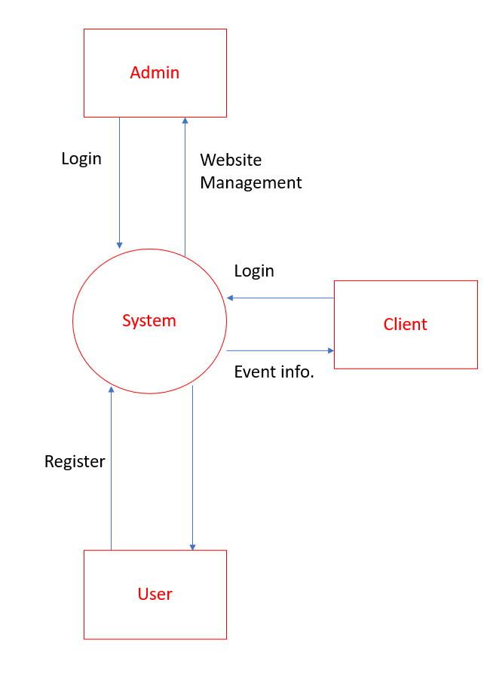

**Level 1 :**

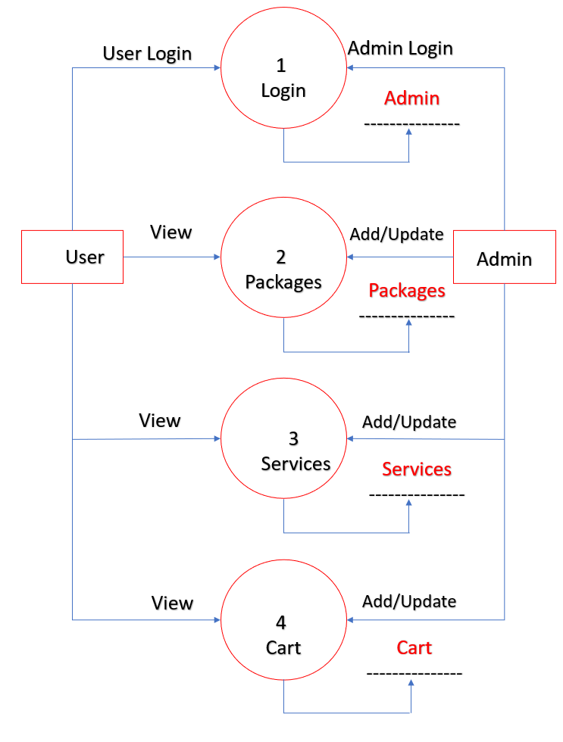

**Level 2.1 :**

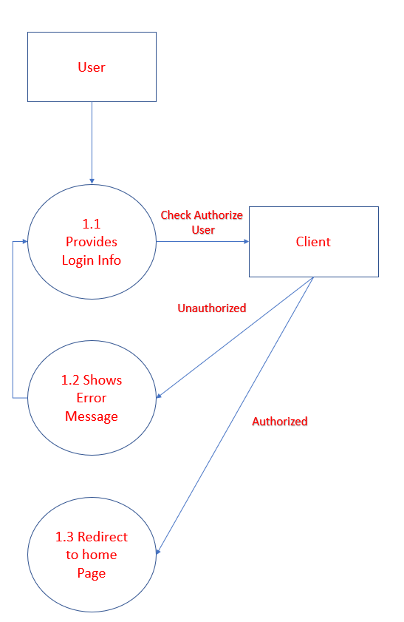

**Level 2.2 :**

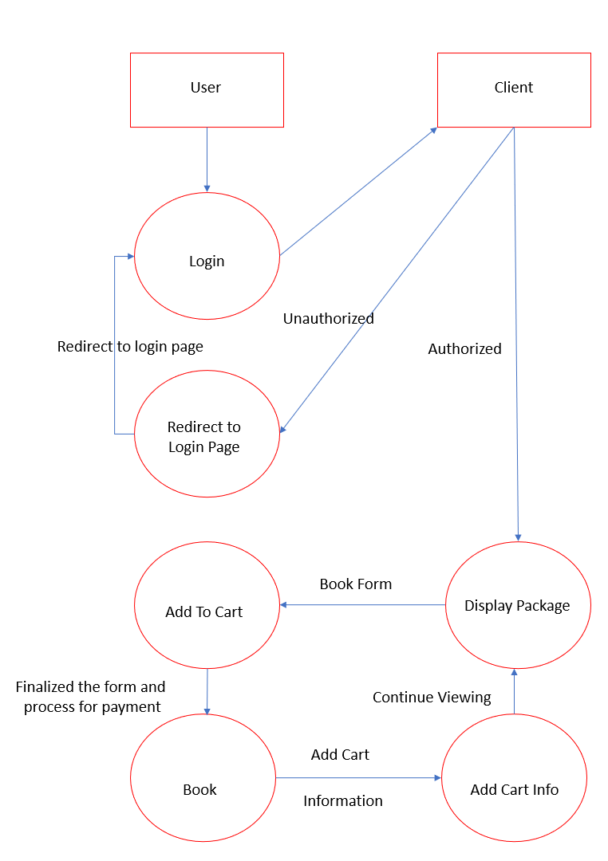

**Level 2.3 :**

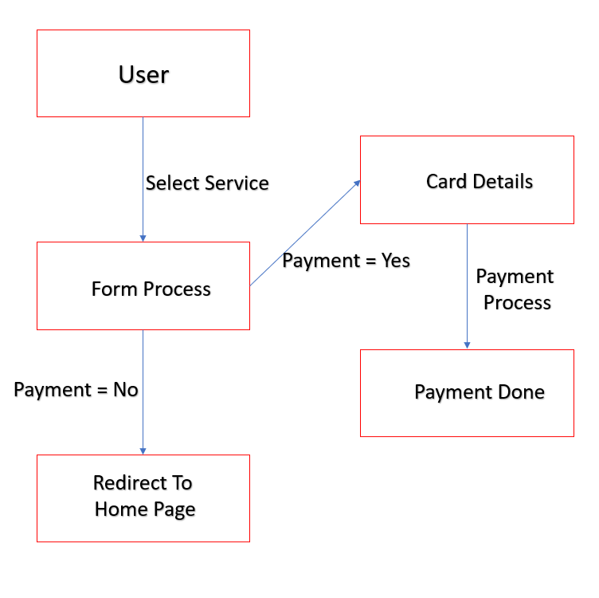

**5.2 Process Specification / Activity Flow Diagram**

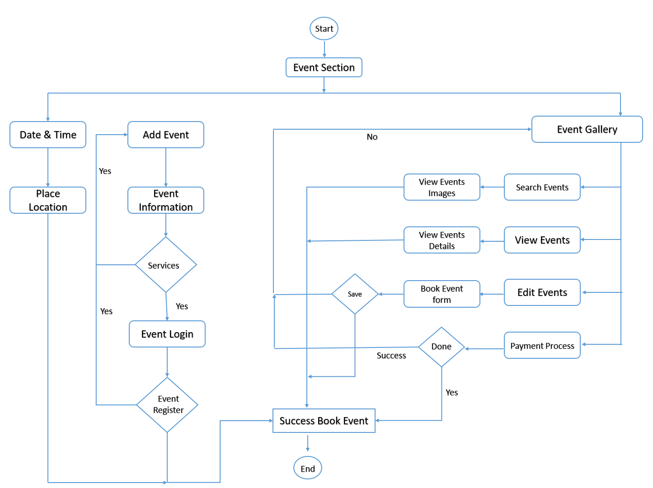

**Use Case Diagram :**

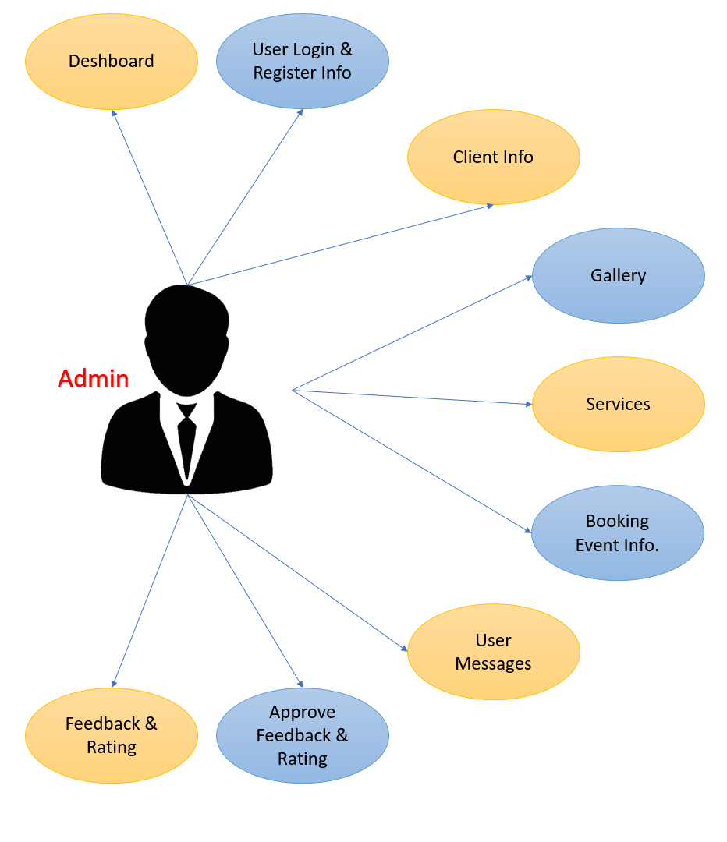

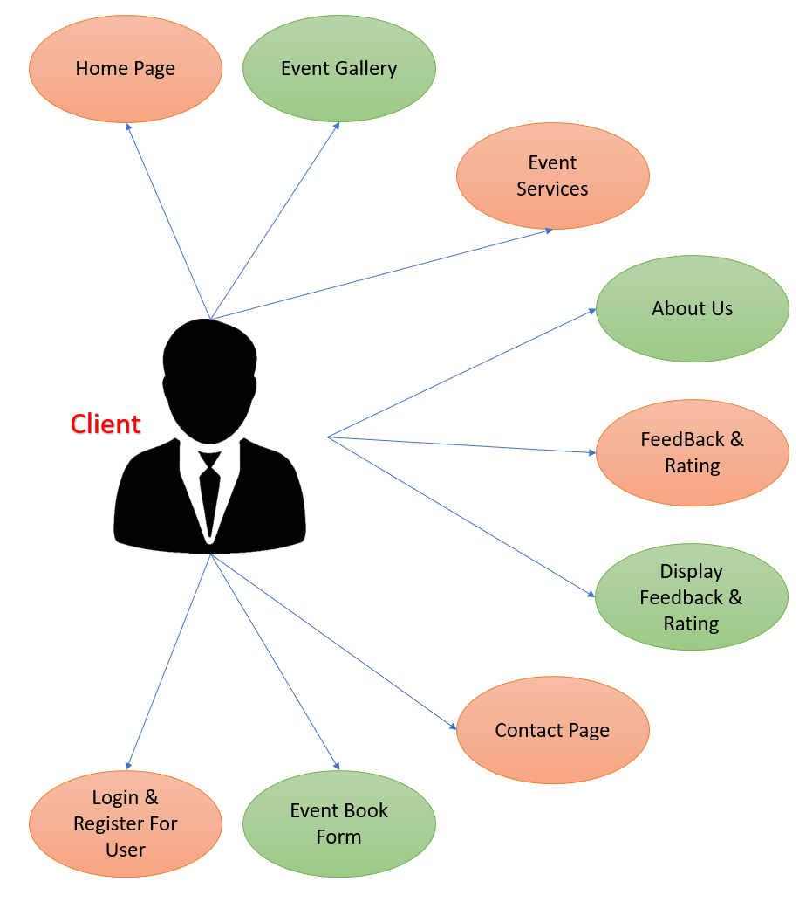

**5.3 Data Dictionary**

|  |  |
| --- | --- |
| USER | |
| Alias | Null |
| Where used/How used | To retrieve or store user details |
| Description | name+email+address+contact+password+repeatpassword+gender |
| Supplementary information | Userid must be unique |

|  |  |
| --- | --- |
| ADMIN | |
| Alias | Null |
| Where used/How used | To retrieve or store admin details |
| Description | name+email +contact |

|  |  |
| --- | --- |
| ClIENT | |
| Alias | Null |
| Where used/How used | To retrieve or store clients details |
| Description | M_details+place_location+event_list |

**5.4 Entity-Relationship Diagram / Class Diagram**

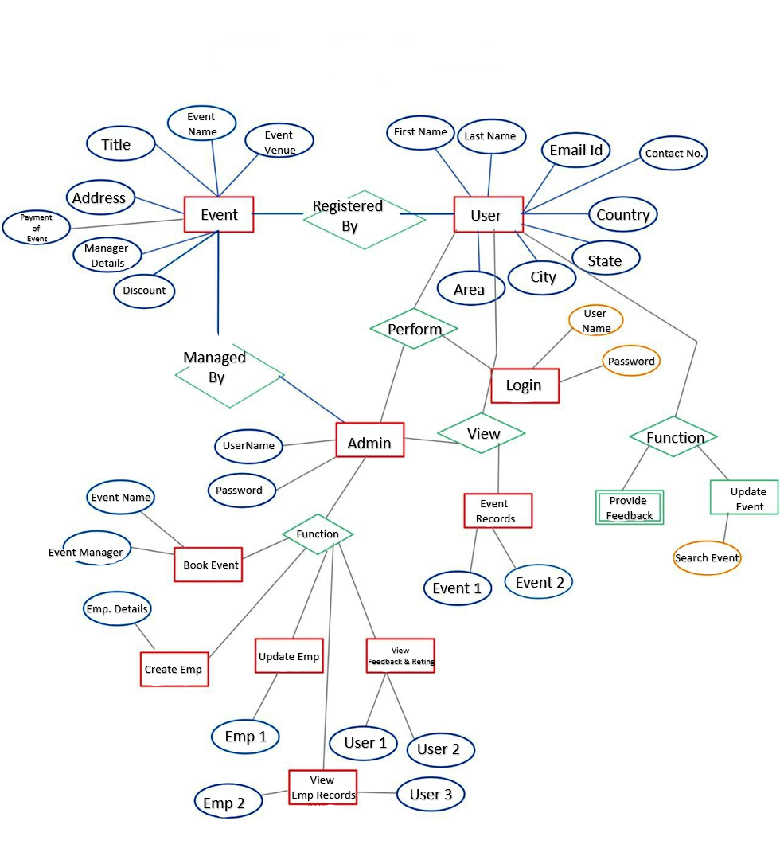

**6. System Design**

**6.1 Database Design** Database Name : ‘event’

Table name : ‘book_form’ Table Description :

|  |  |  |
| --- | --- | --- |
| **ID** | **NAME** | **TYPE** |
| 1 | u_id | int(11) |
| 2 | u_fname | varchar(30) |
| 3 | u_lname | varchar(30) |
| 4 | u_email | varchar(30) |
| 5 | u_contact | bigint(11) |
| 6 | u_adddress | varchar(30) |
| 7 | e_state | varchar(30) |
| 8 | e_city | varchar(30) |
| 9 | e_area | varchar(30) |
| 10 | e_place | varchar(30) |
| 11 | e_date | date |
| 12 | e_time | varchar(30) |
| 13 | e_rprice | int(11) |
| 14 | e_dectype | varchar(30) |
| 15 | e_memnum | varchar(30) |
| 16 | e_decprice | int(11) |
| 17 | e_plan | varchar(30) |
| 18 | e_food | varchar(30) |
| 19 | em_name | varchar(30) |
| 20 | em_email | varchar(30) |
| 21 | em_contact | bigint(11) |
| 22 | em_place | varchar(30) |
| 23 | em_rprice | int(11) |
| 24 | em_dprice | int(11) |
| 25 | em_tprice | int(11) |
| 26 | u_discount | varchar(30) |

Table name : ‘emp_details’ Table Description :

|  |  |  |
| --- | --- | --- |
| **ID** | **NAME** | **TYPE** |
| 1 | em_id | int(11) |
| 2 | em_name | varchar(30) |
| 3 | em_email | varchar(30) |
| 4 | em_contact | bigint(11) |
| 5 | em_location | varchar(30) |
| 6 | em_no | int(11) |

Table name : ‘eu_login’ Table Description :

|  |  |  |
| --- | --- | --- |
| **ID** | **NAME** | **TYPE** |
| 1 | u_id | int(11) |
| 2 | u_email | varchar(30) |
| 3 | u_passwrod | varchar(30) |

Table name : ‘eu_registration’ Table Description :

|  |  |  |
| --- | --- | --- |
| **ID** | **NAME** | **TYPE** |
| 1 | u_id | int(11) |
| 2 | u_fname | varchar(30) |
| 3 | u_lname | varchar(30) |
| 4 | u_address | varchar(30) |
| 5 | u_email | varchar(30) |
| 6 | u_contact | bigint(11) |
| 7 | u_password | varchar(30) |
| 8 | u_rptpwd | varchar(30) |

Table name : ‘e_state’ Table Description :

|  |  |  |
| --- | --- | --- |
| ID | NAME | TYPE |
| 1 | state_id | int(11) |
| 2 | state_name | varchar(30) |
| 3 | state_no | int(11) |

Table name : ‘e_city’ Table Description :

|  |  |  |
| --- | --- | --- |
| ID | NAME | TYPE |
| 1 | city_id | int(11) |
| 2 | city_name | varchar(30) |
| 3 | city_no | int(11) |

Table name : ‘e_area’ Table Description :

|  |  |  |
| --- | --- | --- |
| ID | NAME | TYPE |
| 1 | area_id | int(11) |
| 2 | area_name | varchar(30) |
| 3 | area_no | int(11) |

Table name : ‘e_place’ Table Description :

|  |  |  |
| --- | --- | --- |
| ID | NAME | TYPE |
| 1 | place_id | int(11) |
| 2 | place_name | varchar(30) |
| 3 | place_no | int(11) |

Table name : ‘e_rent’ Table Description :

|  |  |  |
| --- | --- | --- |
| ID | NAME | TYPE |
| 1 | rent_id | int(11) |
| 2 | rent | int(11) |
| 3 | rent_no | int(11) |

Table name : ‘e_dectype’ Table Description :

|  |  |  |
| --- | --- | --- |
| ID | NAME | TYPE |
| 1 | dectype_id | int(11) |
| 2 | dectype_name | varchar(30) |
| 3 | dectype_no | int(11) |

Table name : ‘e_decprice’ Table Description :

|  |  |  |
| --- | --- | --- |
| ID | NAME | TYPE |
| 1 | decprice_id | int(11) |
| 2 | decprice | int(11) |
| 3 | decprice_no | int(11) |

Table name : ‘e_gallery’ Table Description :

|  |  |  |
| --- | --- | --- |
| **ID** | **NAME** | **TYPE** |
| 1 | eg_id | int(11) |
| 2 | eg_img | varchar(30) |
| 3 | eg_name | varchar(30) |

Table name : ‘e_service’ Table Description :

|  |  |  |
| --- | --- | --- |
| **ID** | **NAME** | **TYPE** |
| 1 | id | int(11) |
| 2 | image | text |
| 3 | title | varchar(30) |
| 4 | description | varchar(1000) |
| 5 | description1 | varchar(1000) |
| 6 | description2 | varchar(1000) |
| 7 | description3 | varchar(1000) |
| 8 | description4 | varchar(1000) |

Table name : ‘e_message’ Table Description :

|  |  |  |
| --- | --- | --- |
| **ID** | **NAME** | **TYPE** |
| 1 | u_id | int(11) |
| 2 | u_name | varchar(30) |
| 3 | u_email | varchar(30) |
| 4 | u_contact | bigint(11) |
| 5 | u_country | varchar(30) |
| 6 | u_subject | varchar(30) |
| 7 | u_message | varchar(30) |

Table name : ‘e_rate_or_feedback’ Table Description :

|  |  |  |
| --- | --- | --- |
| **ID** | **NAME** | **TYPE** |
| 1 | u_id | int(11) |
| 2 | u_email | varchar(30) |
| 3 | u_feedback | varchar(30) |
| 4 | u_rate | varchar(30) |
| 5 | approval_status | enum('pending', 'approved', 'rejected') |

**6.2 Directory Structure**

**Client - Side :**

* Index.php
  + - Header.php
    - Footer.php
* e_gallery.php
* AboutUs.php
  + - e_rating_or_feedback.php
    - e_rating_or_feedback_details.php
  + ContactUs.php
  + Service.php
  + form.php
    - get_states.php
    - get_cities.php
    - get_areas.php
    - get_places.php
    - get_rent_price.php
    - get_decoration_type.php
    - get_decoration_price.php
    - get_manager_details.php
  + submitpayment.php
  + payment-success.php
* bill.php
  + payment-failed.php
  + e_registration.php
  + e_login.php

**Admin - Side :**

DB Connection Page Name : “ connection.php “

**For display information :**

* + - main.php
    - Index.php
    - admin-contact.php
    - admin-profile.php
    - user-login-show-info.php
    - user-login-update-info.php
    - user-register-show-info.php
    - user-register-update-info.php
    - client-show-info.php
      * client-home.php
      * client-show-state.php
      * client-show-city.php
      * client-show-area.php
      * client-show-place.php
      * client-show-rent-price.php
      * client-show-dec-type.php
      * client-show-dec-price.php
      * client-show-mngr-details.php
    - client-update-info.php
    - client-display-info.php
    - client-gallery-show.php
    - client-gallery-update.php
    - client-service-show.php
    - client-service-update.php
    - user-book-info-show.php
    - user-msg-info.php
    - user-book-info-update.php
    - pending-fdbk-and-rtng.php
    - fdbk_and_rtng.php.php

**For Data Management :** Update & Delete Data Pages Name :

* + - * User-register-data-update.php
      * User-register-data-delete.php
      * User-login-data-update.php
      * User-login-data-delete.php
      * User-book-data-update.php
      * Client-gallery-data-add.php
      * Client-gallery-data-delete.php
      * Client-gallery-data-update.php
      * Client-service-data-update.php
      * Client-fdbk-rtng-data-update.php

**6.3 Input Design**

**Client Side :**

index.php



e_gallery.php

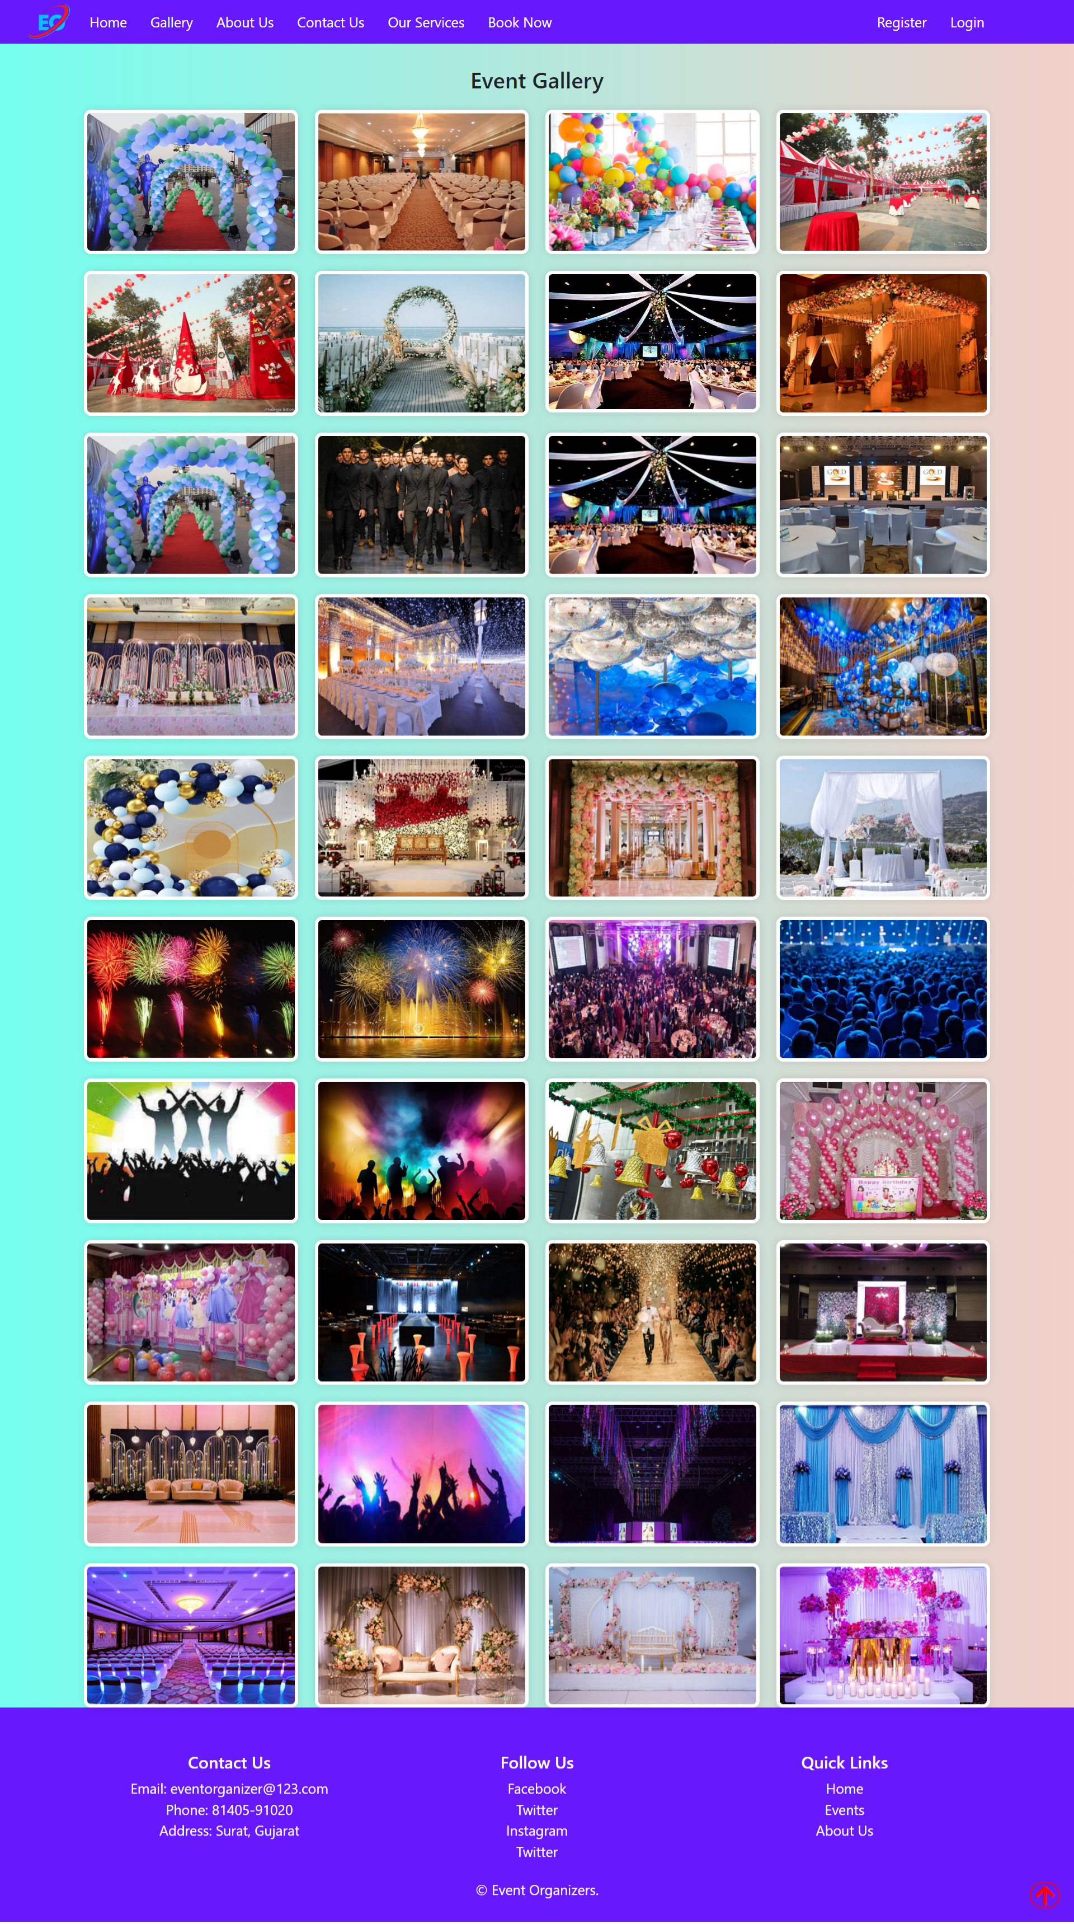

AboutUs.php / e_rating_or_feedback.php

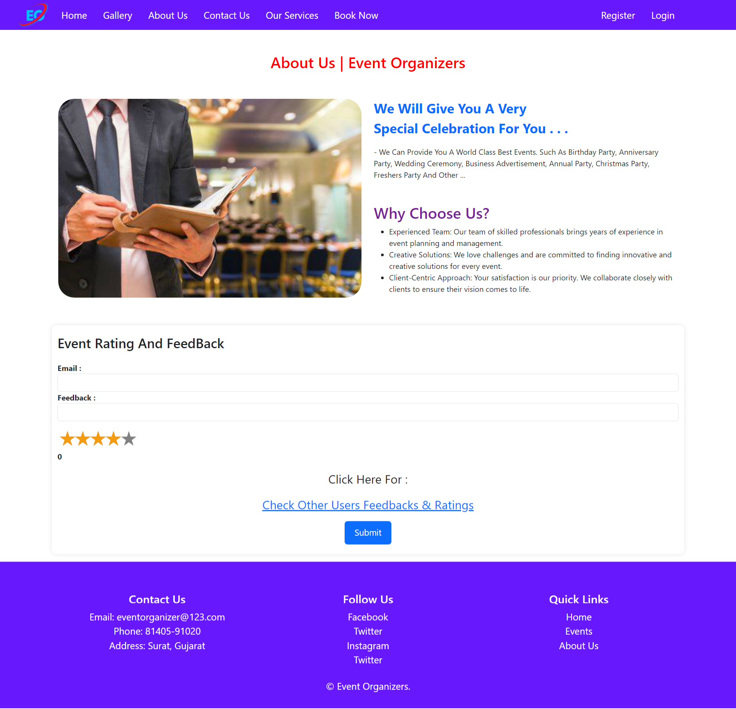

e_rating_or_feedback_details.php

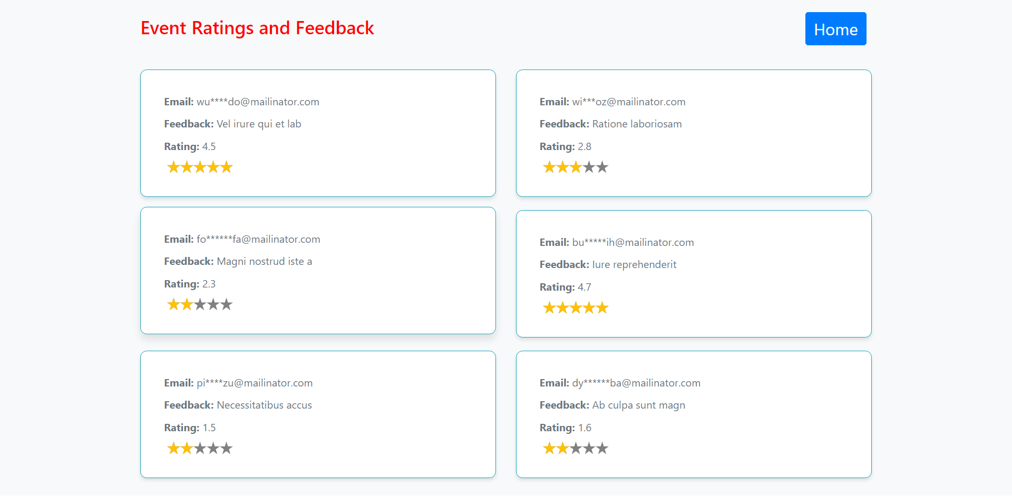

ContactUs.php

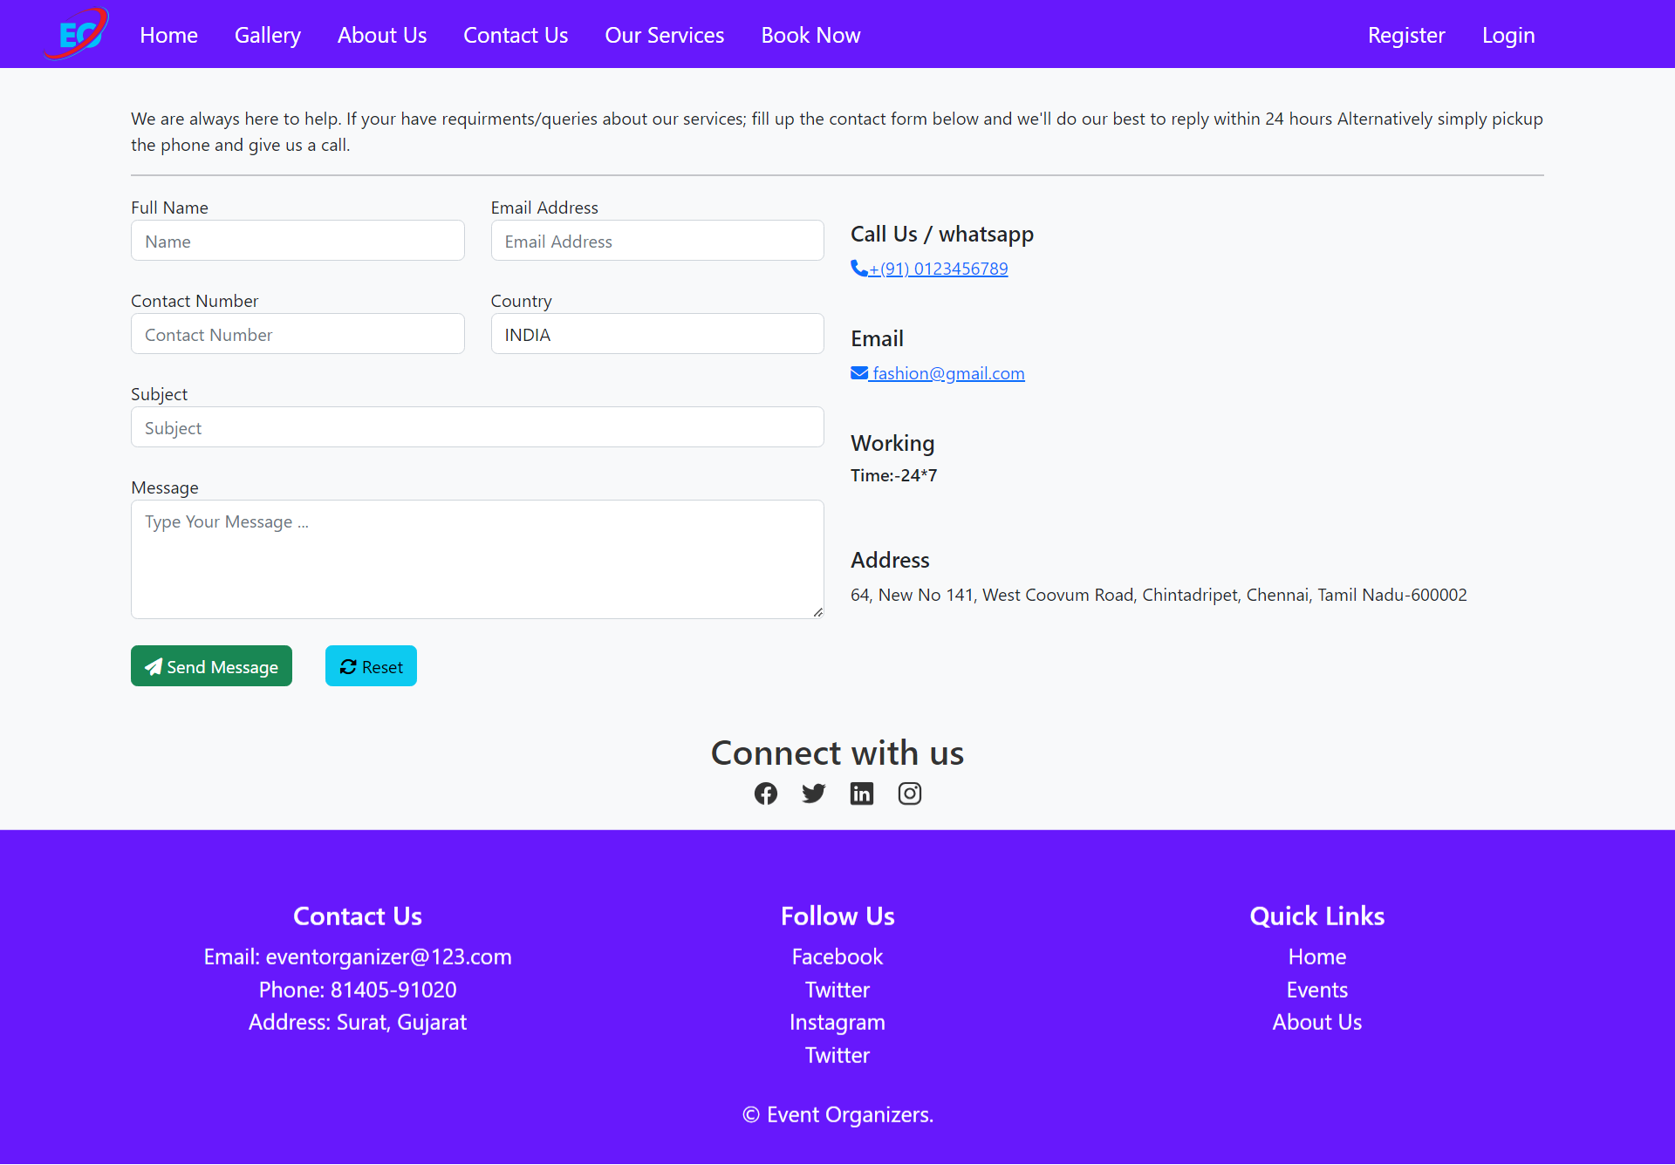

Service.php

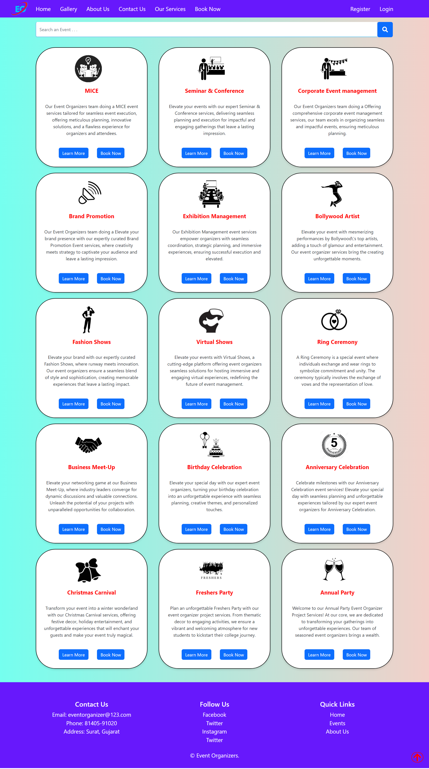

Service/Cards-Learn More:

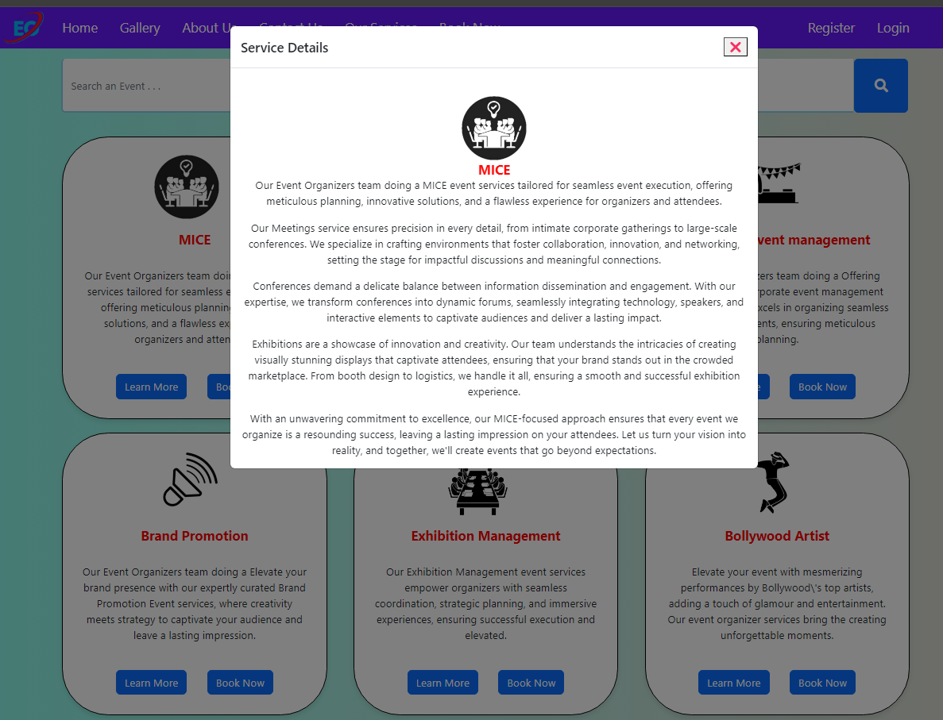

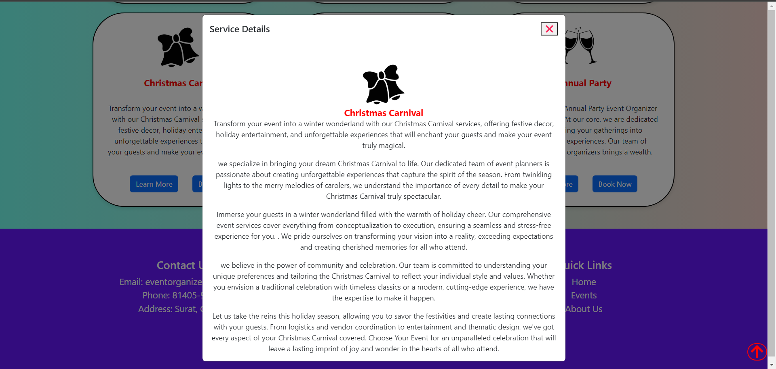

Form.php

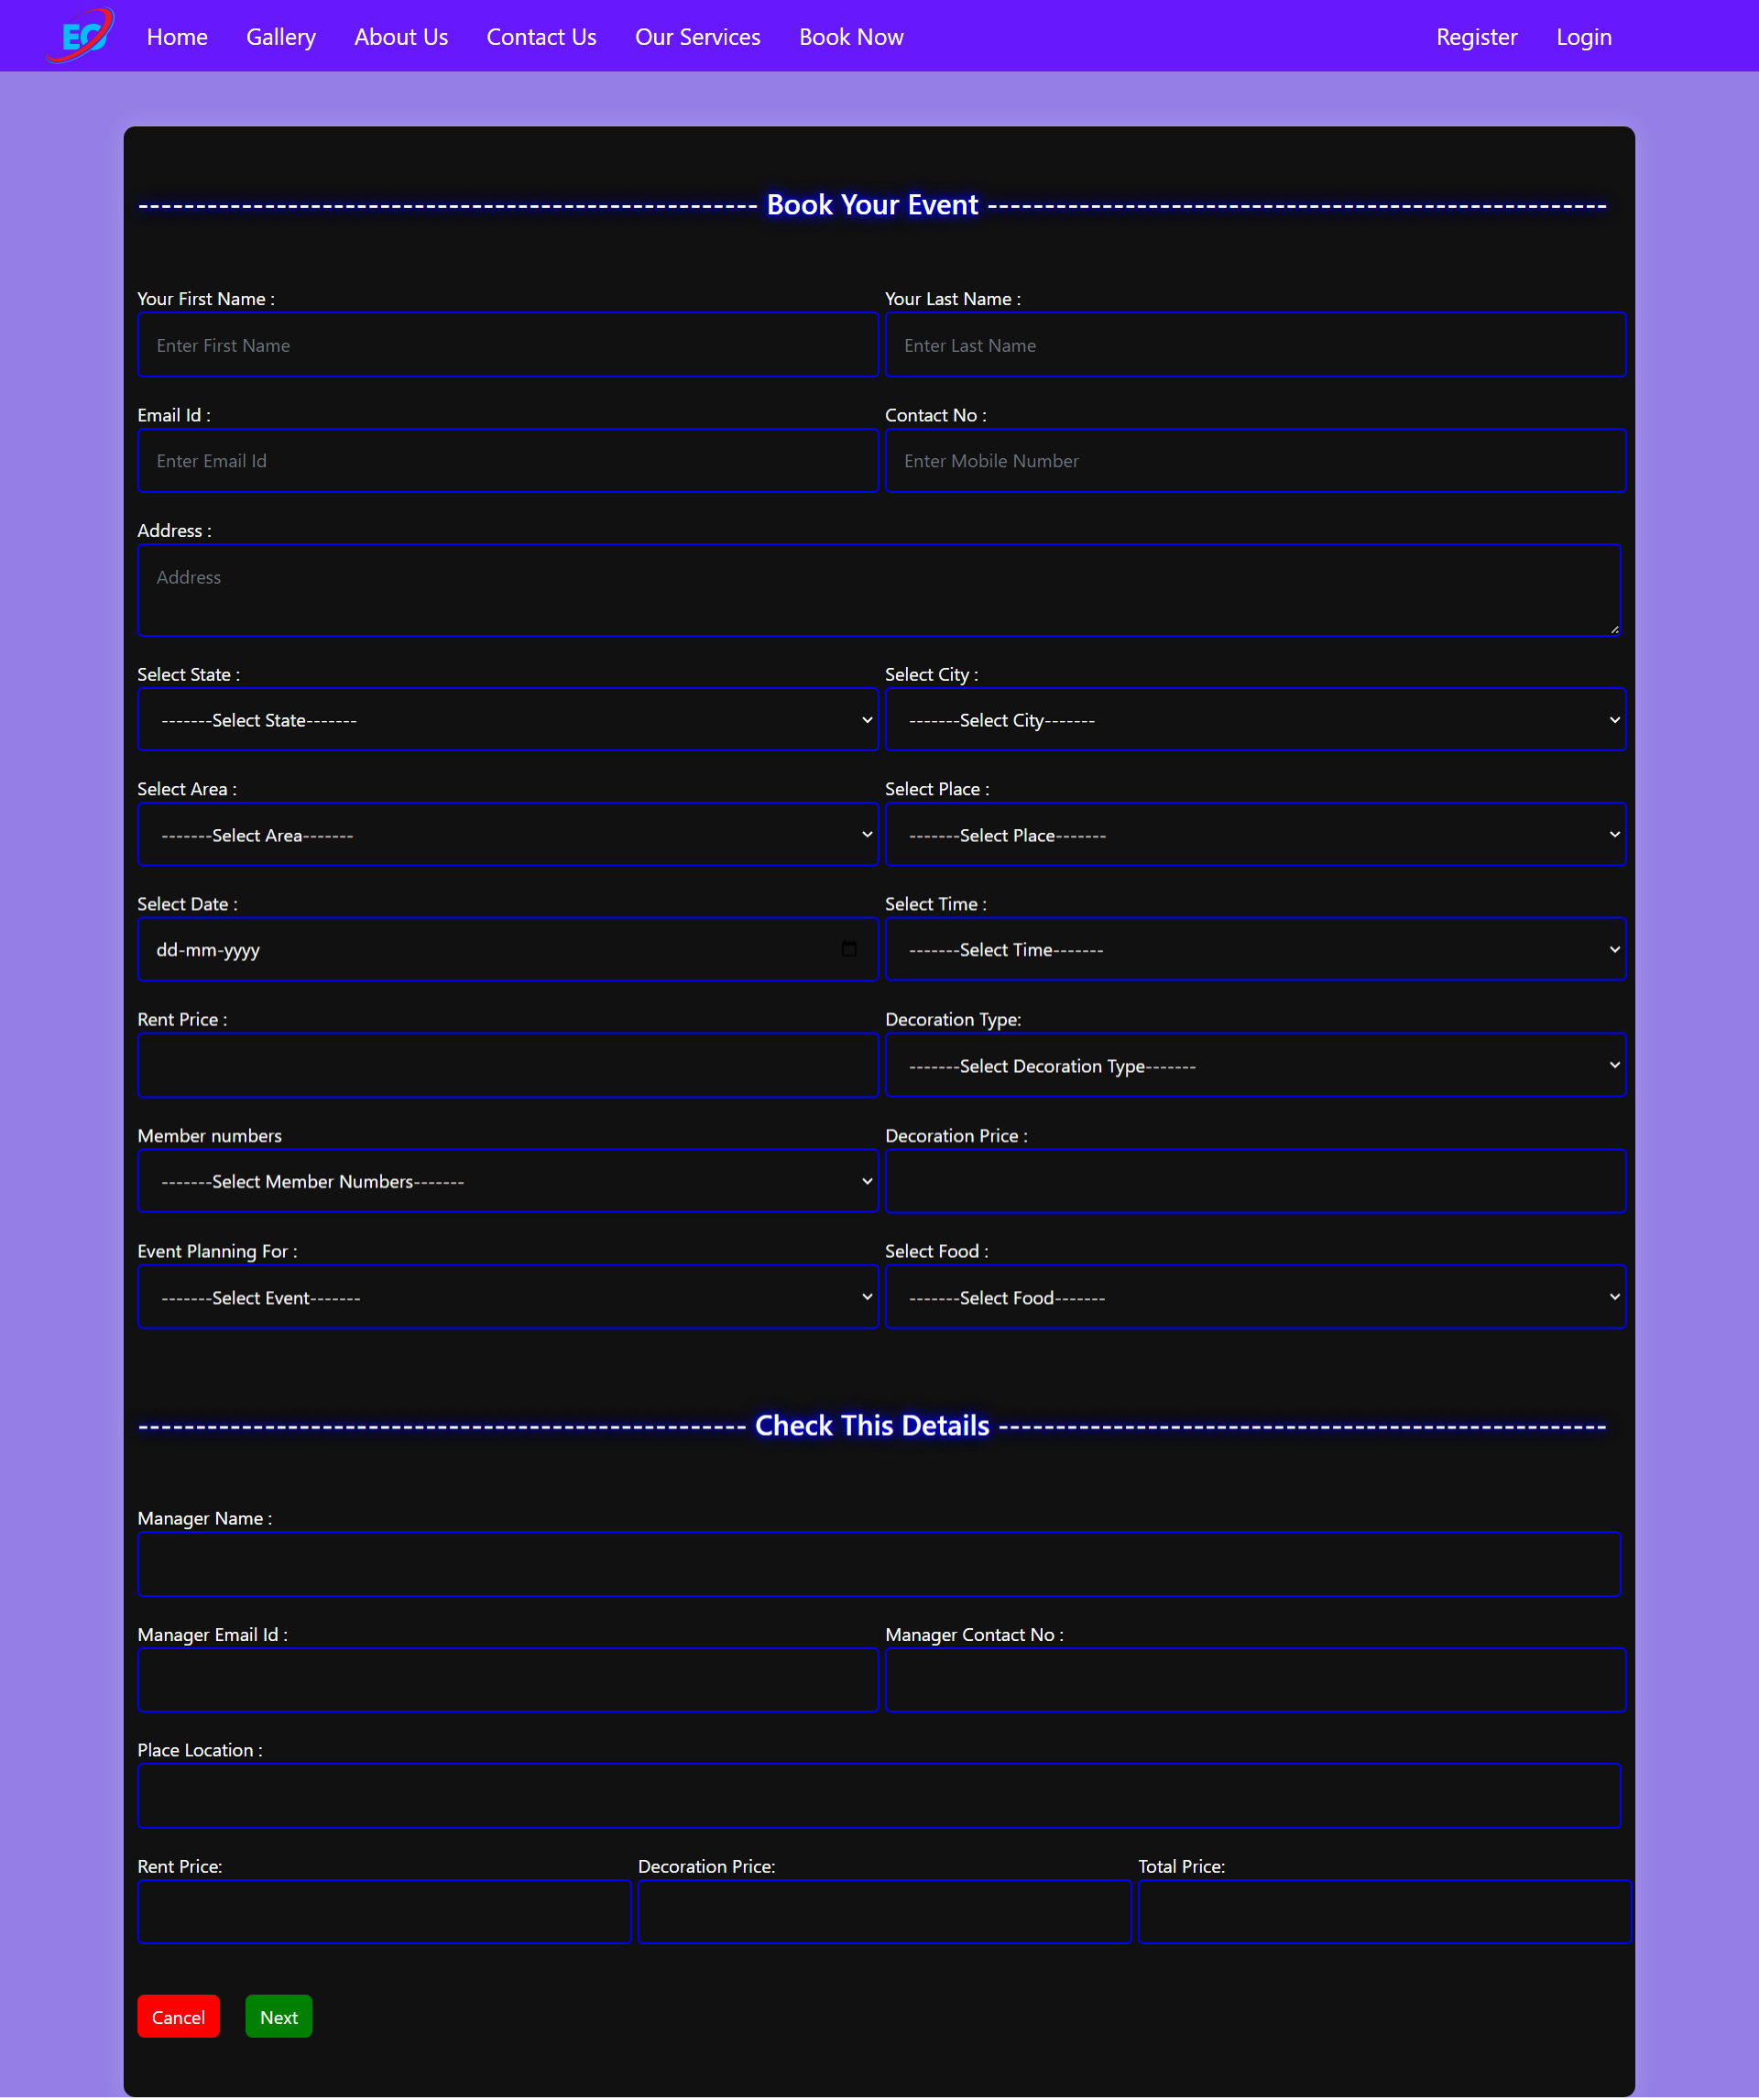

submitPayment.php

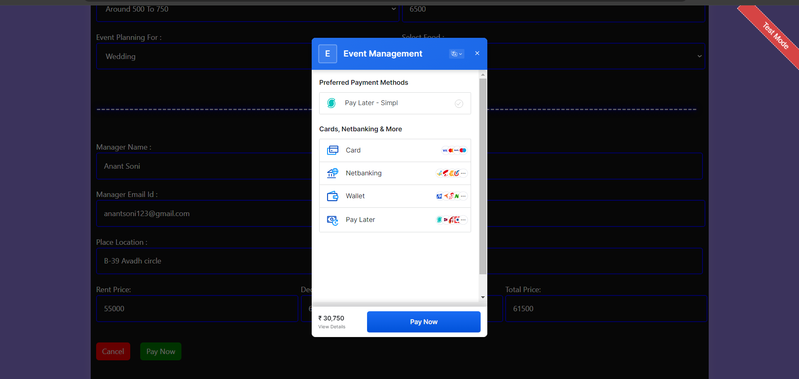

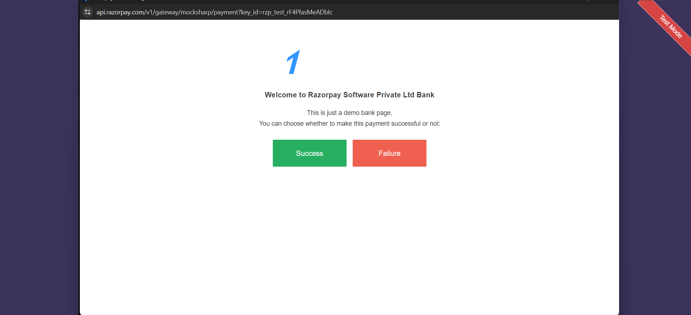

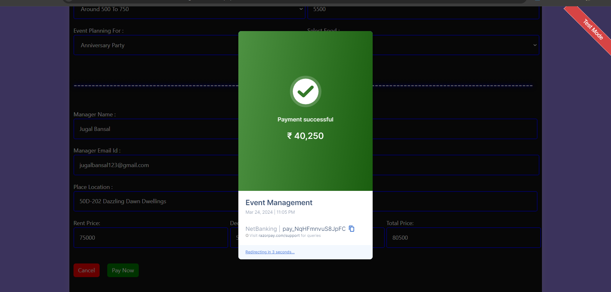

bill.php

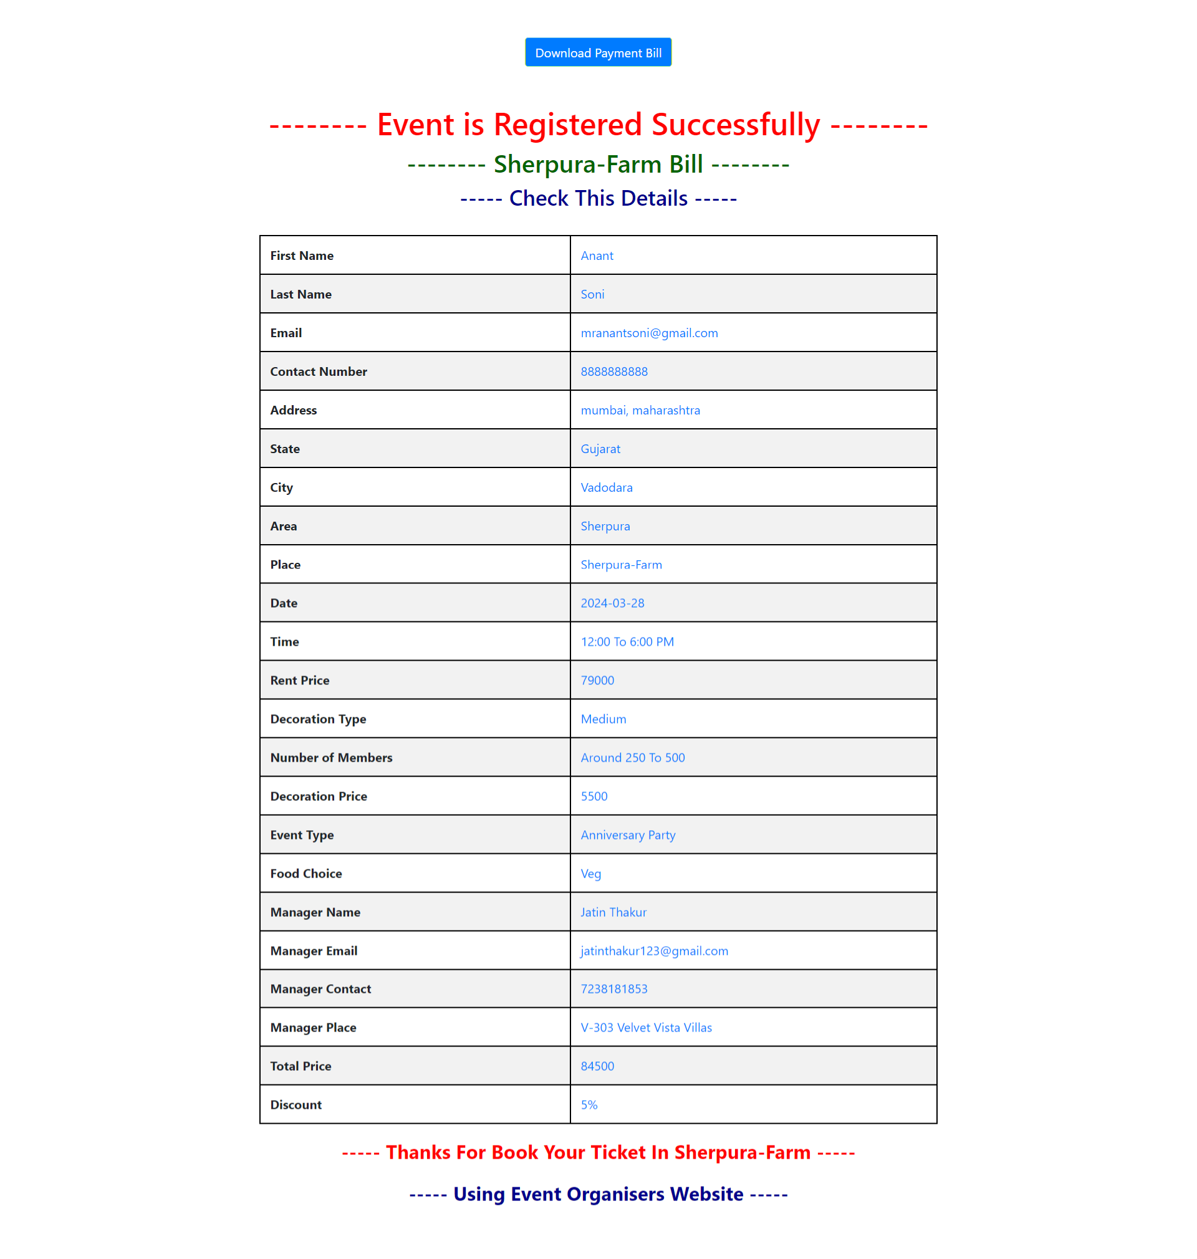

e_registration.php

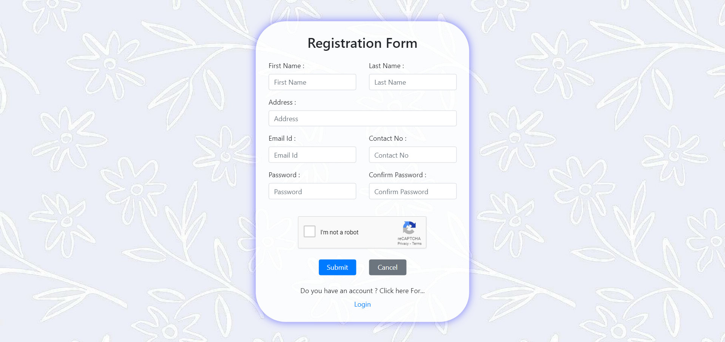

e_login.php



**Admin Side :**

Main.php

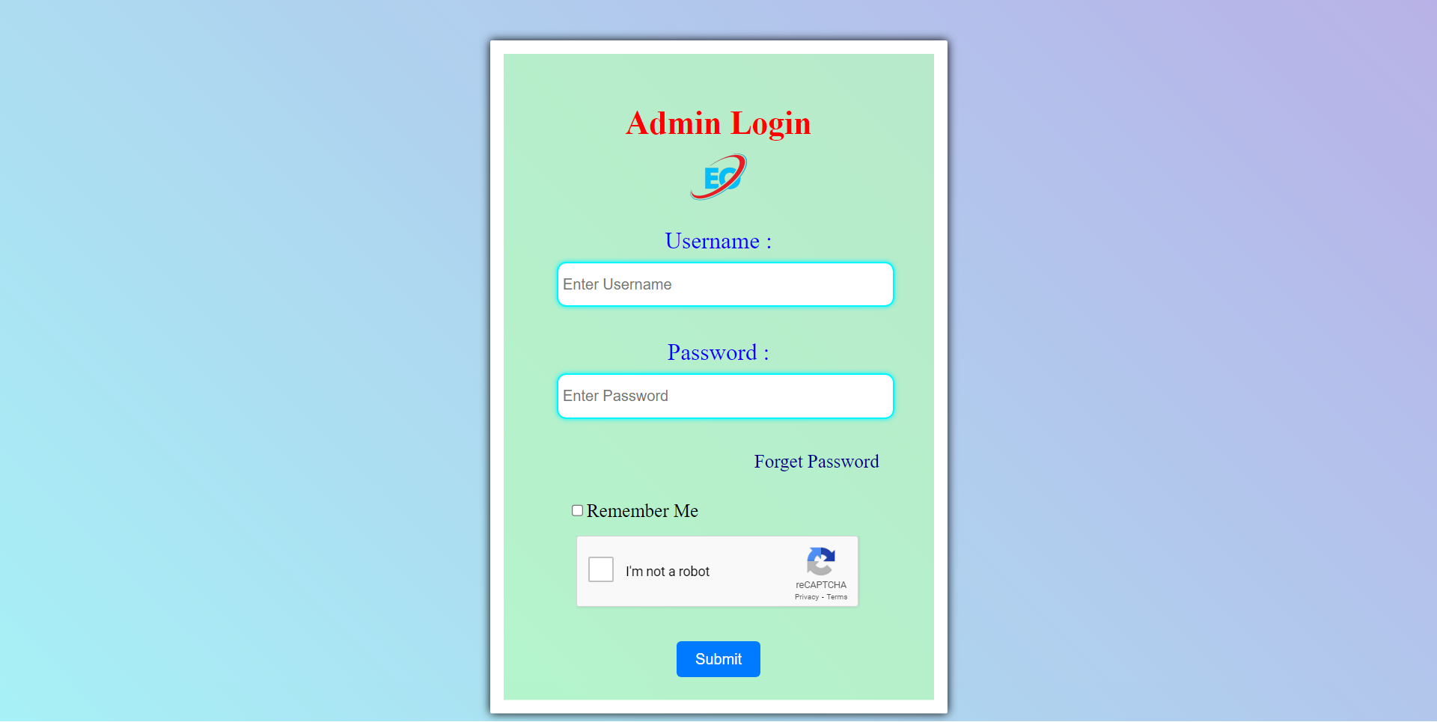

Index.php

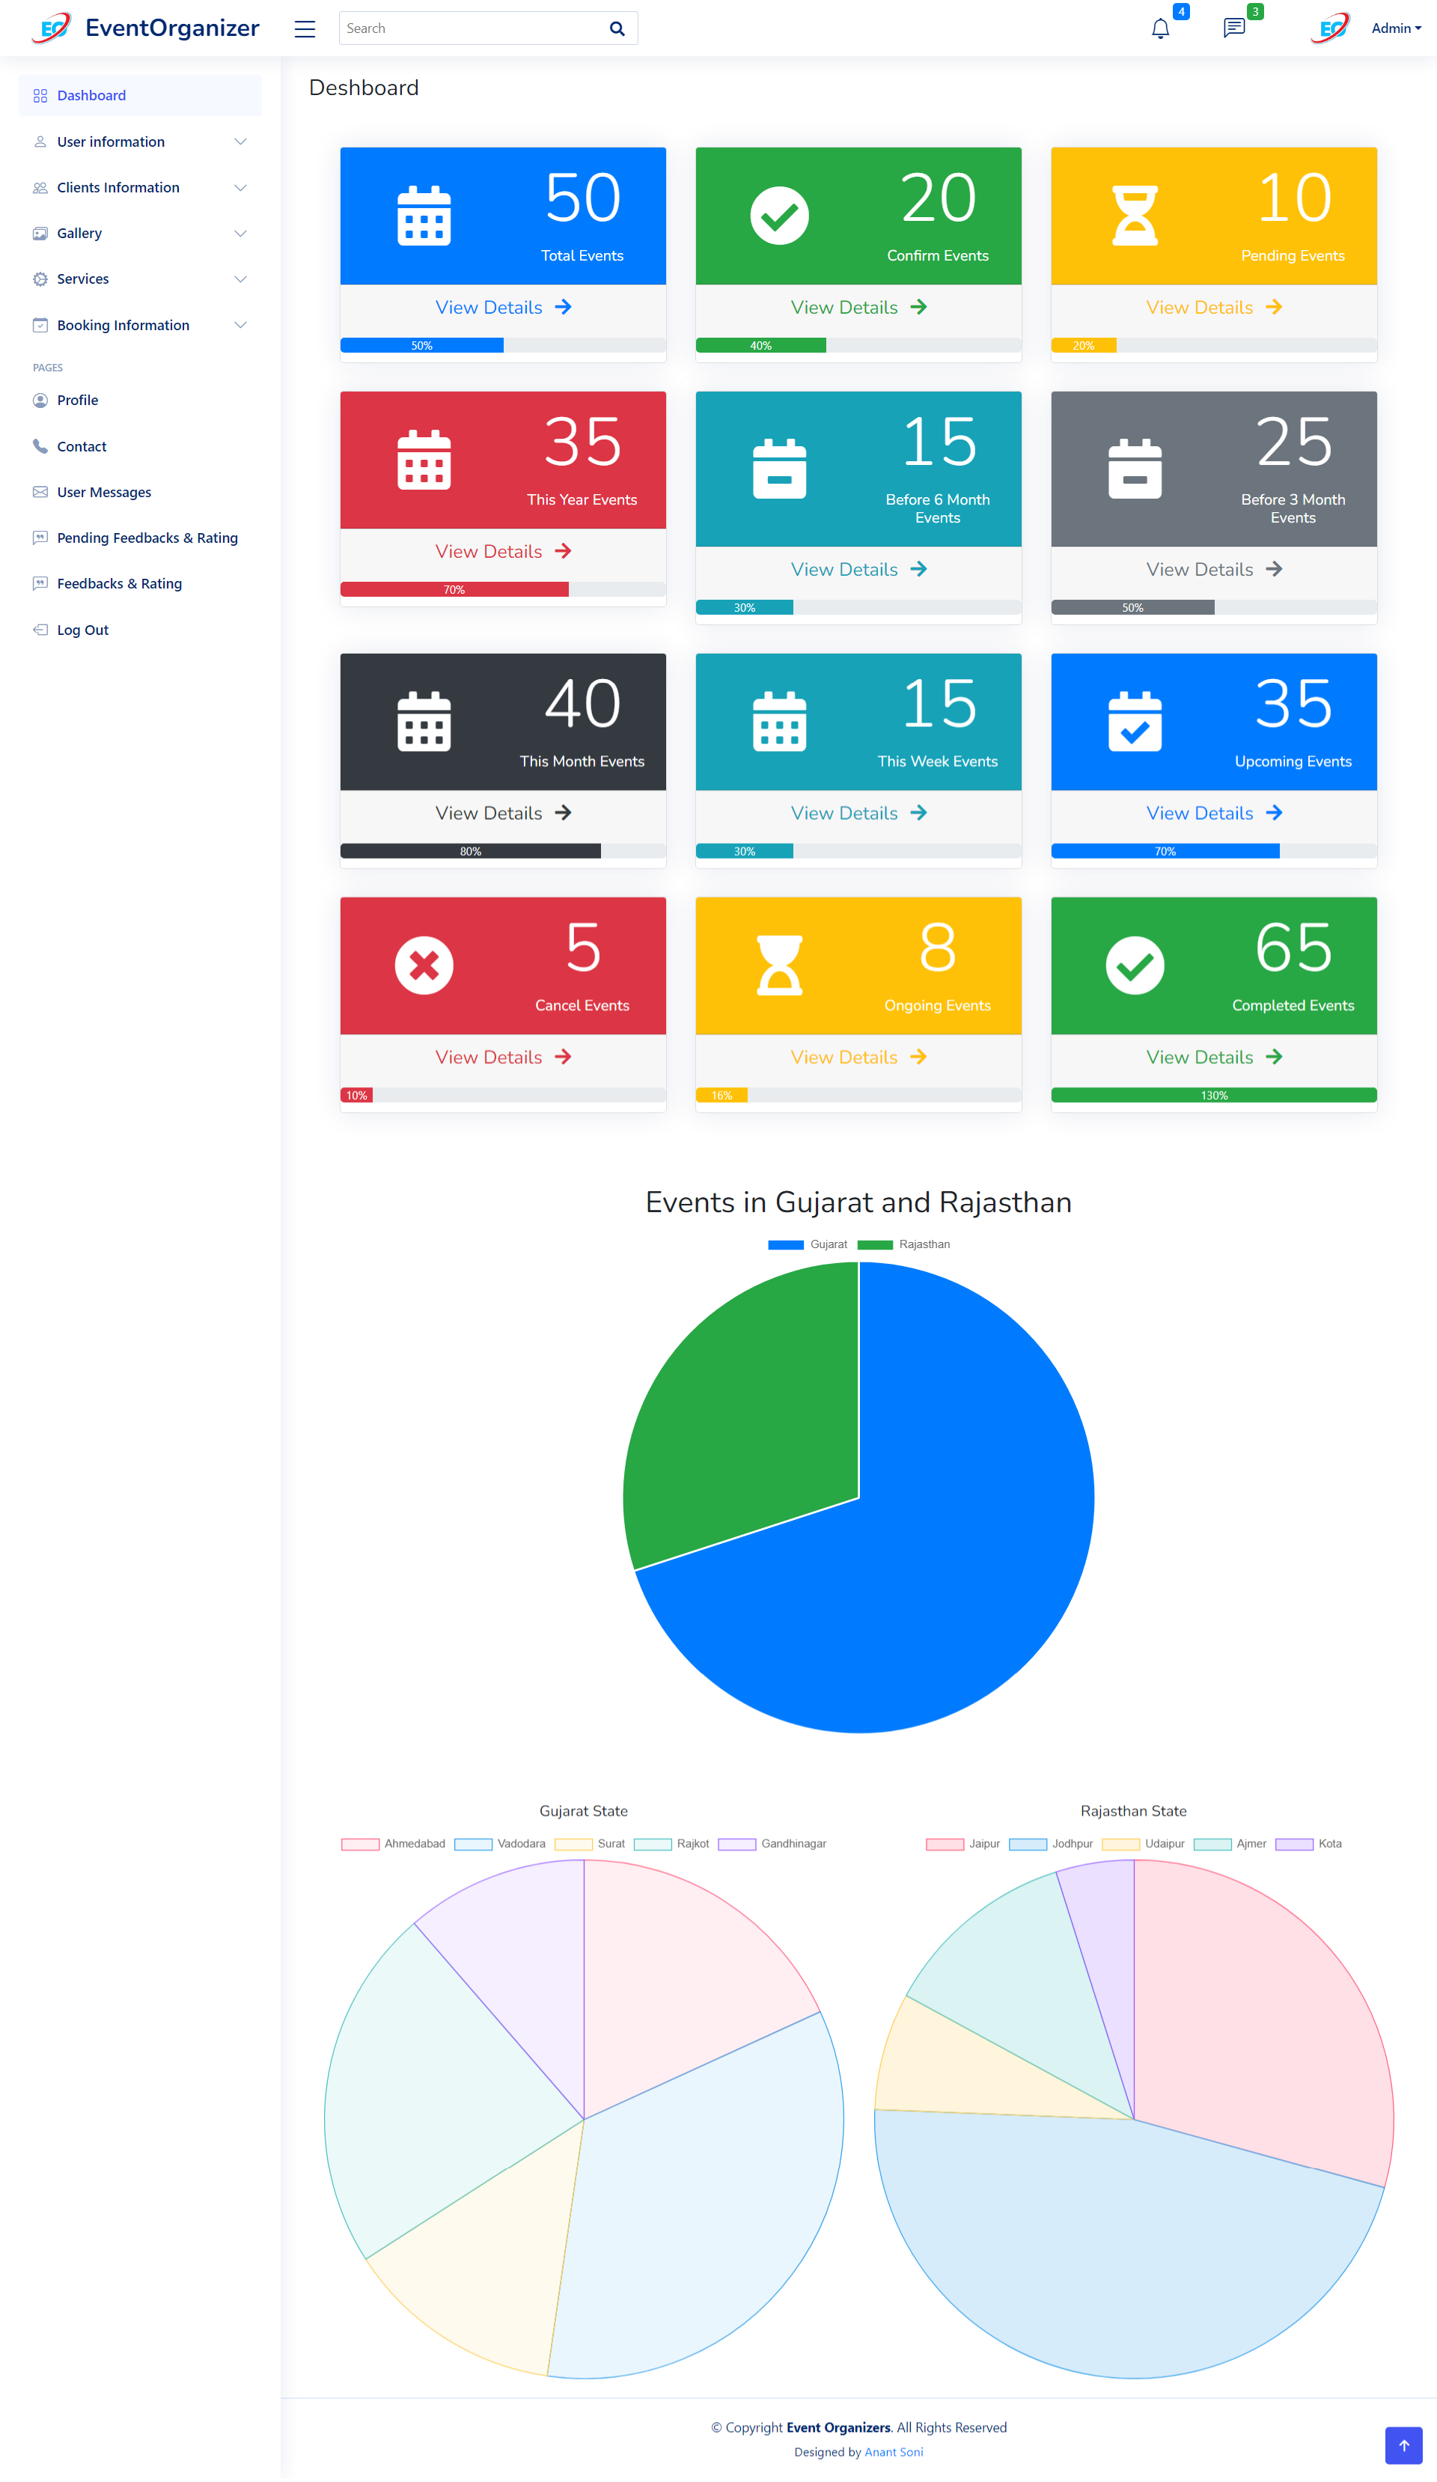

User-login-show-info.php

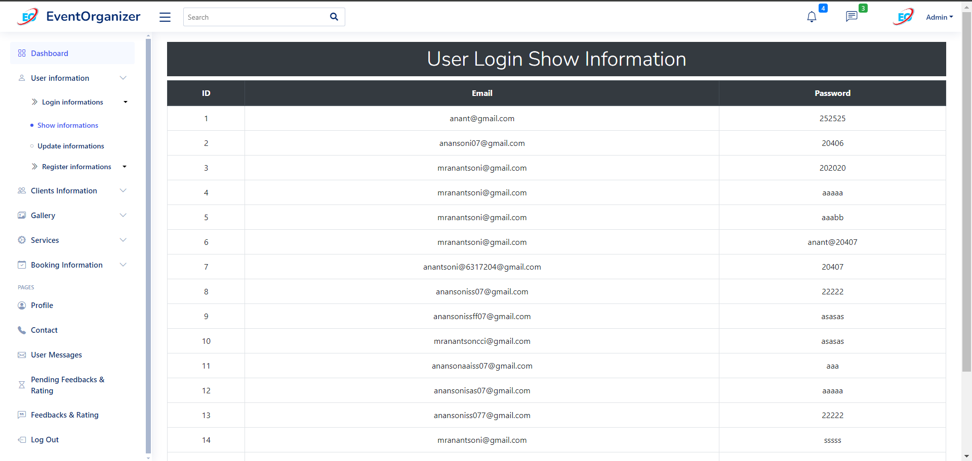

User-login-update-info.php

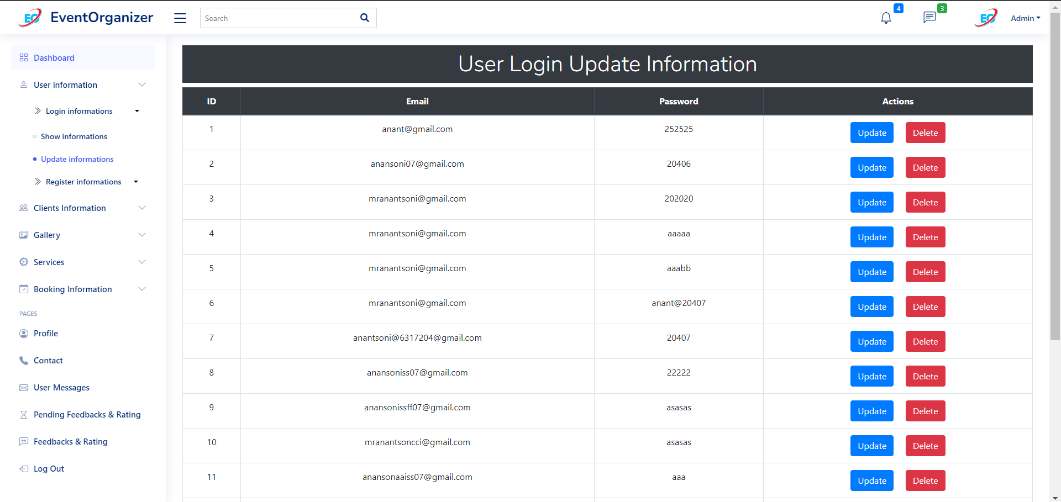

user-register-show-info.php

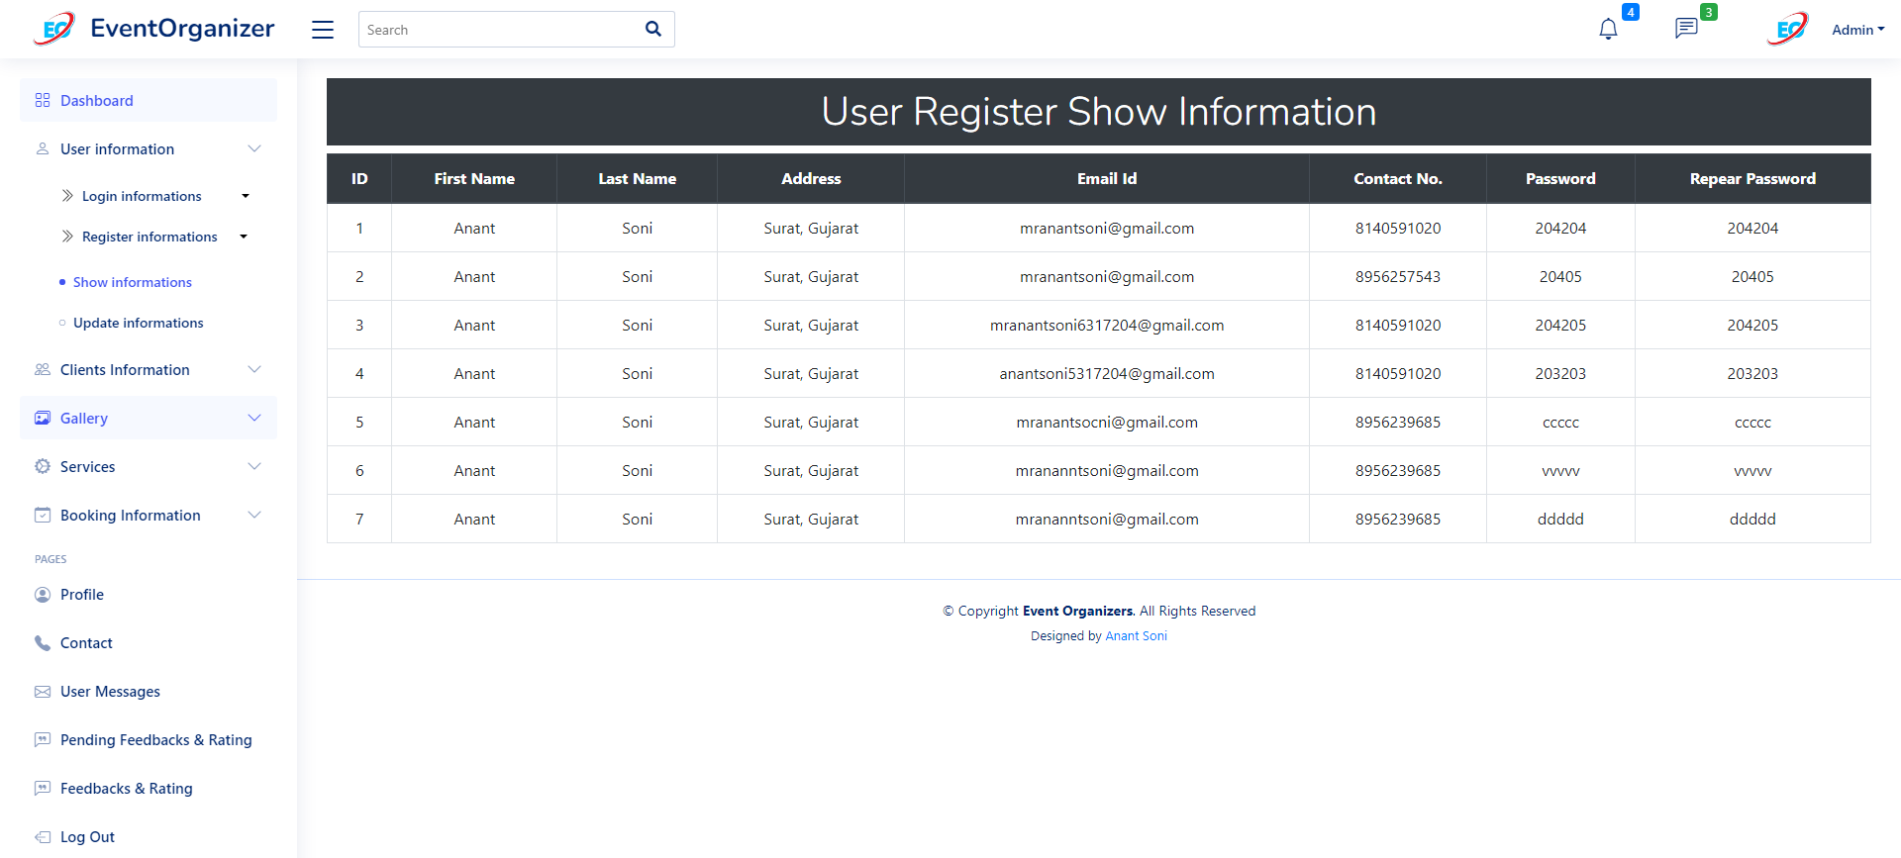

user-register-update-info.php

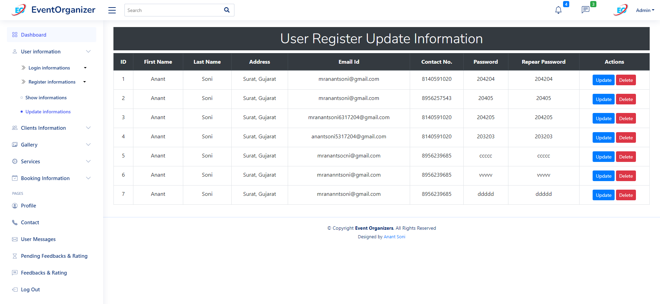

client-show-info.php

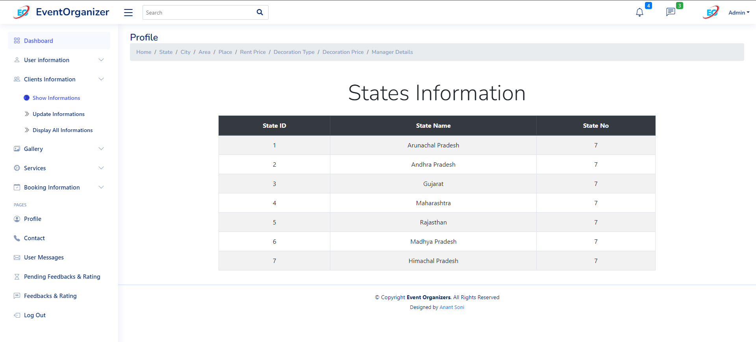

client-update-info.php

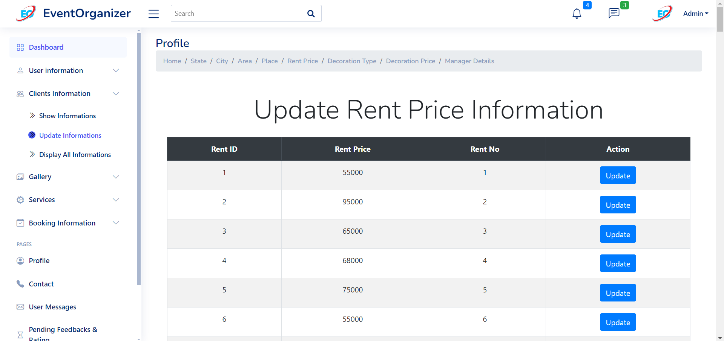

client-display-info.php

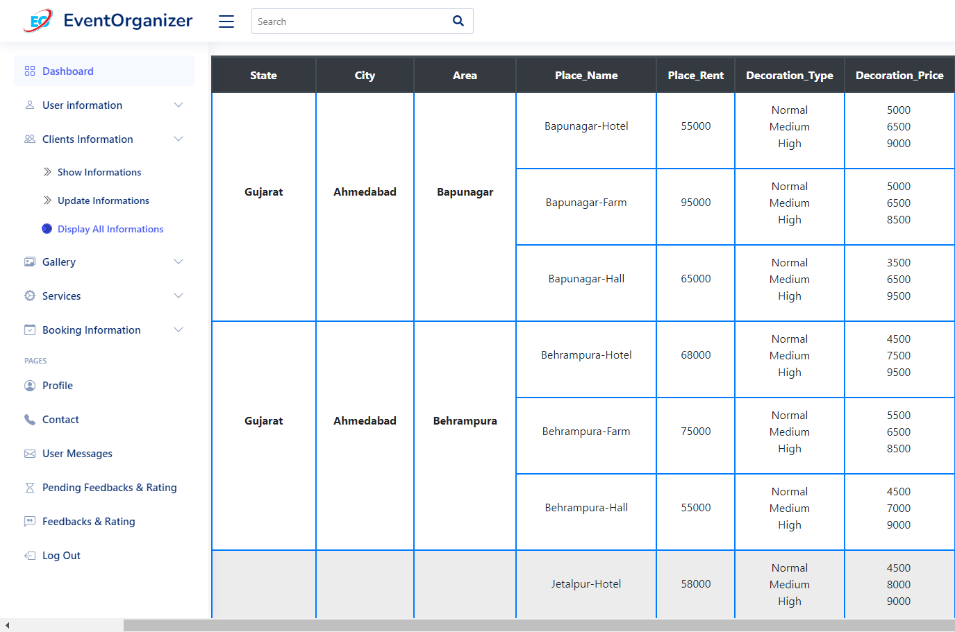

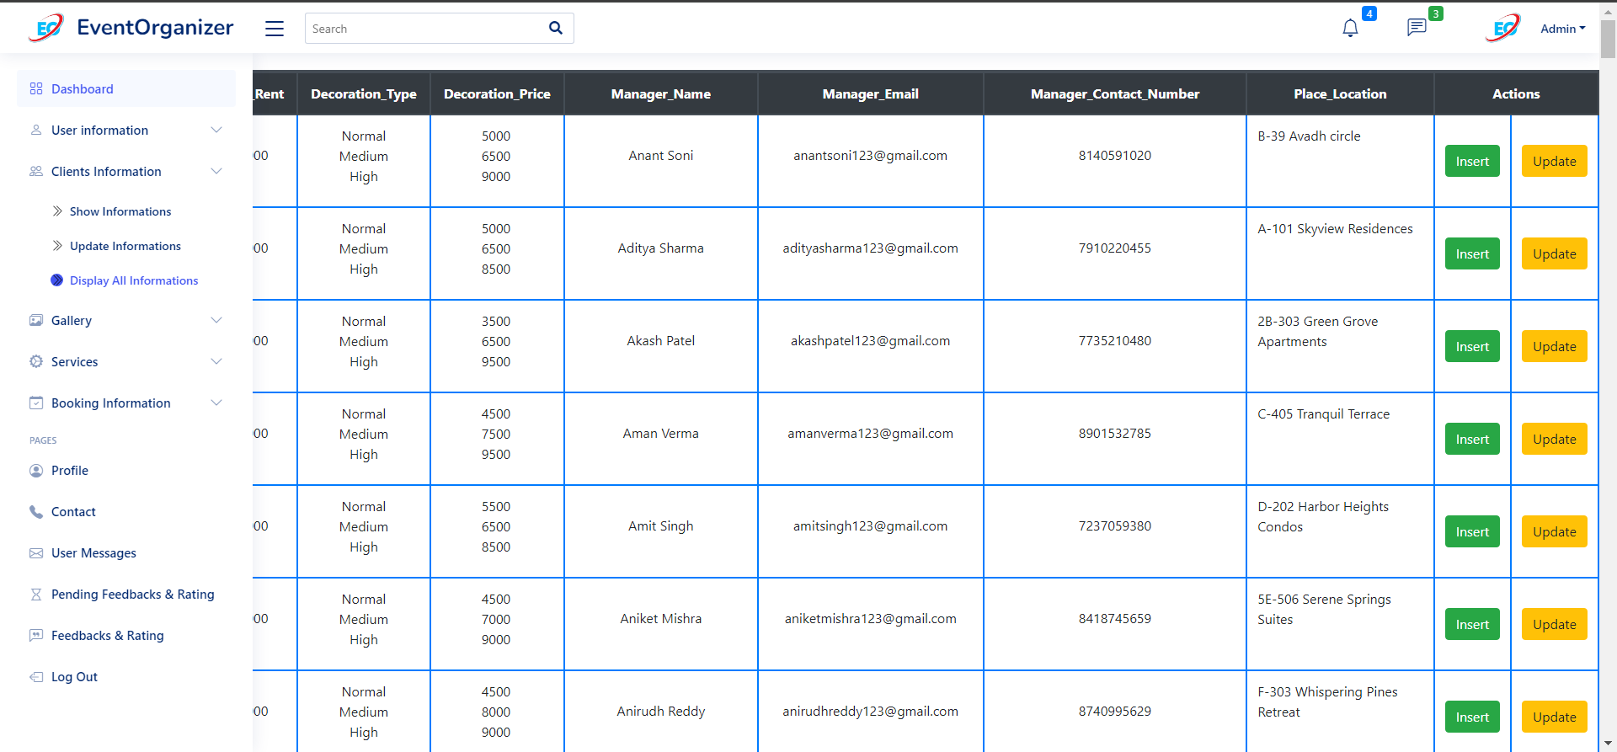

client-gallery-show.php

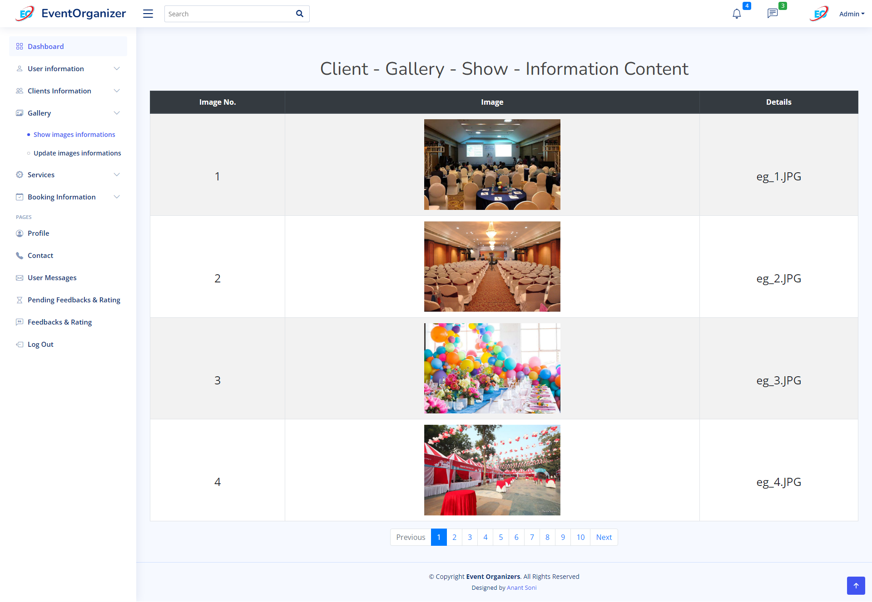

client-gallery-update.php

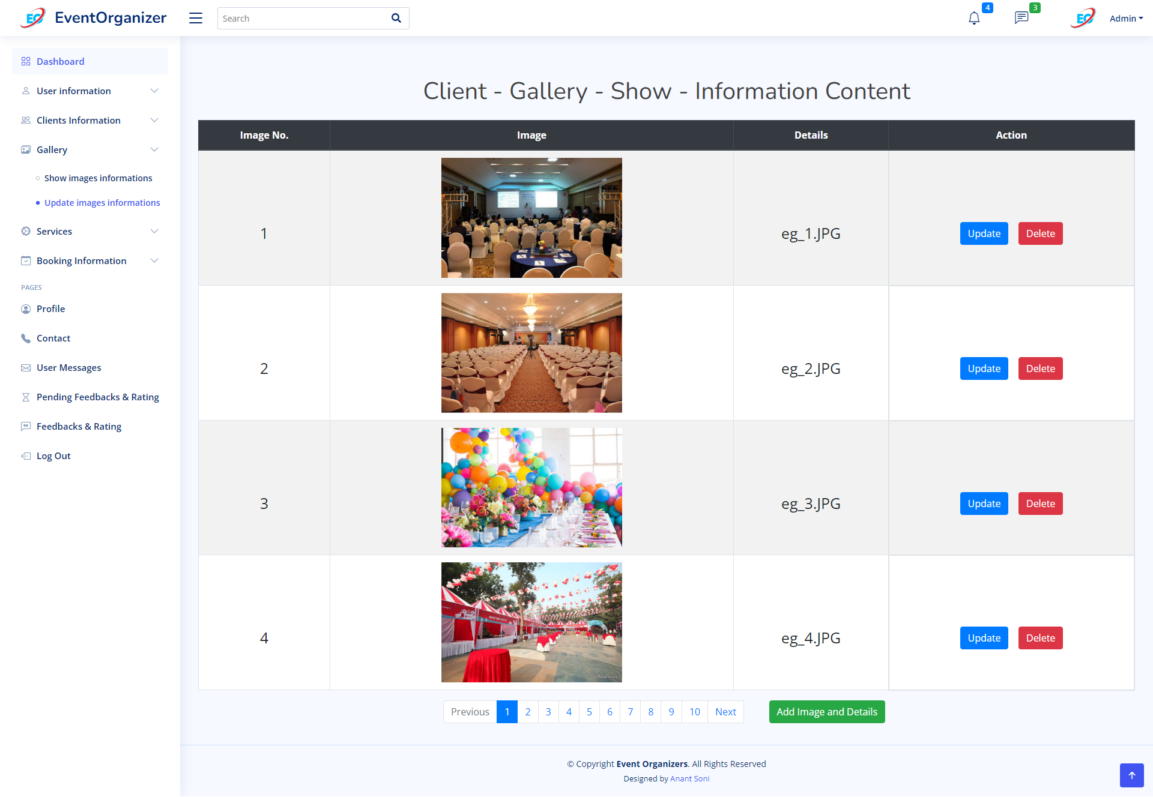

client-service-show.php

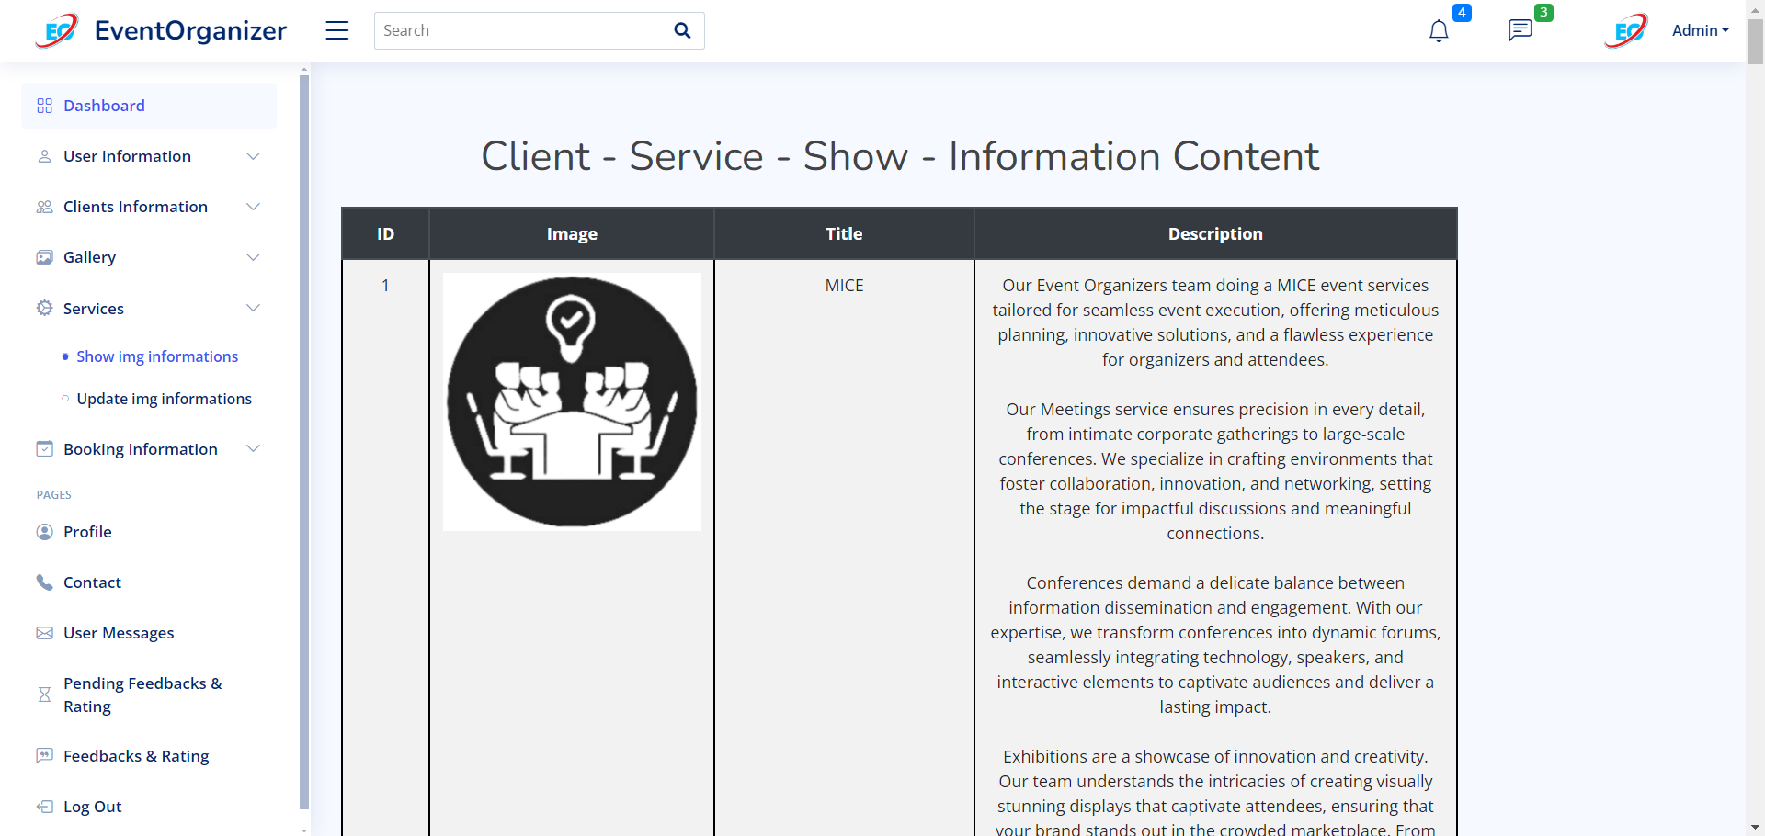

client-service-update.php

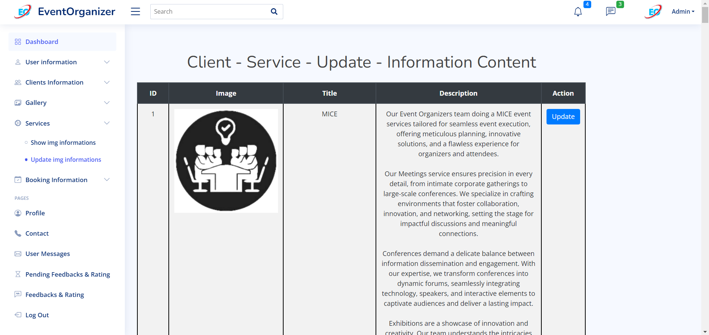

user-book-info-show.php

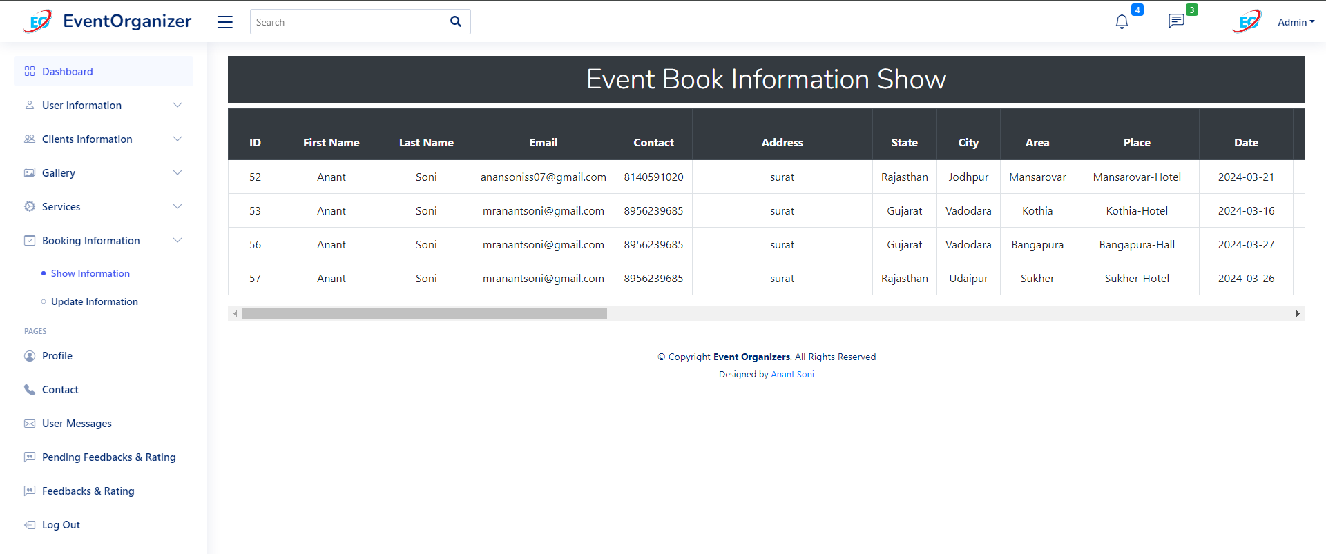

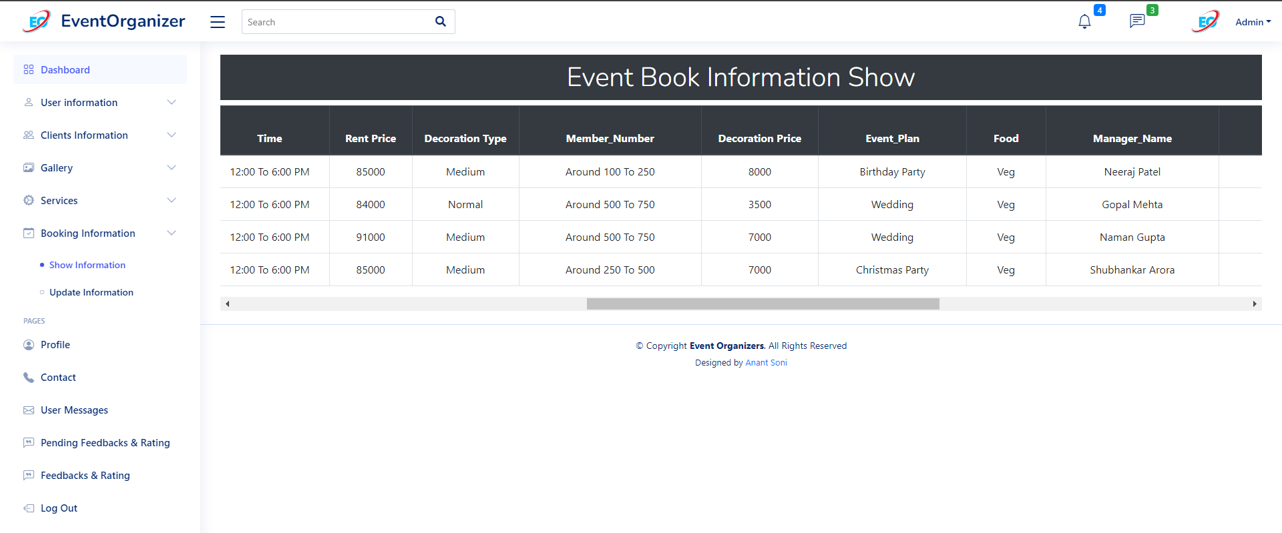

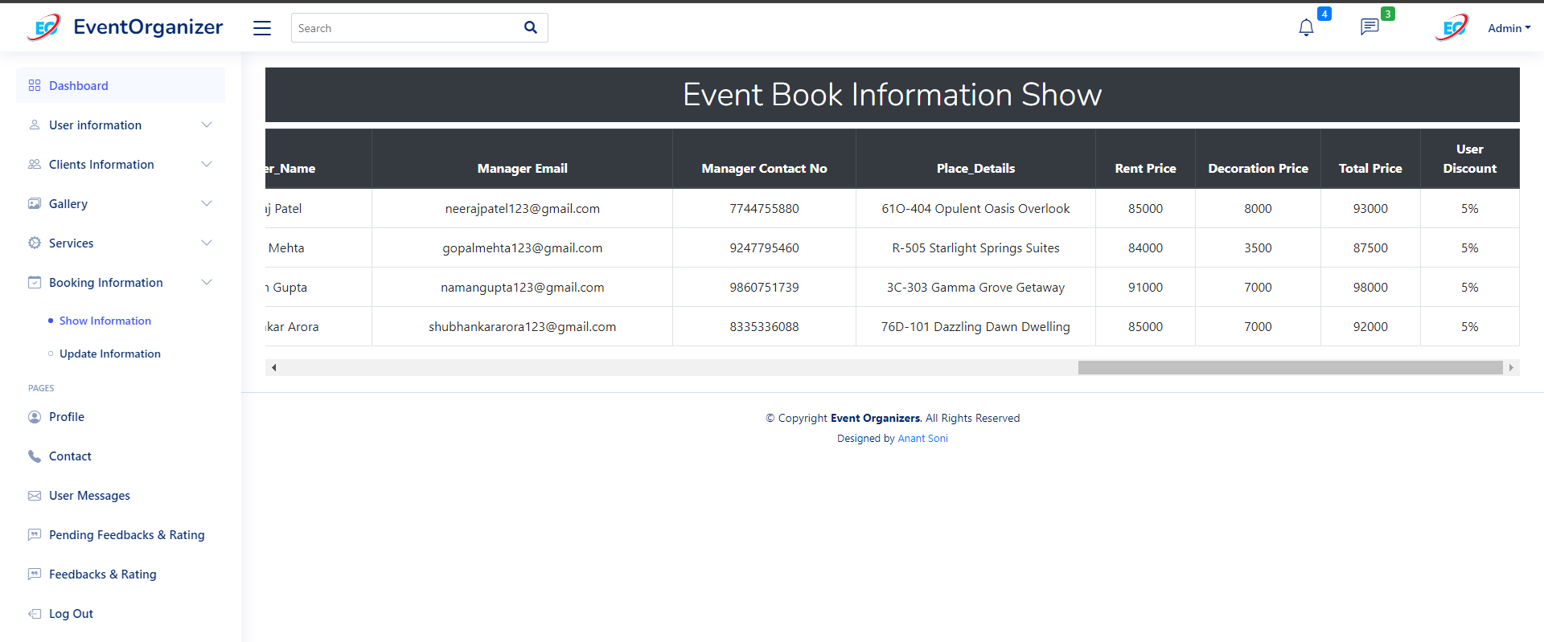

user-book-info-update.php

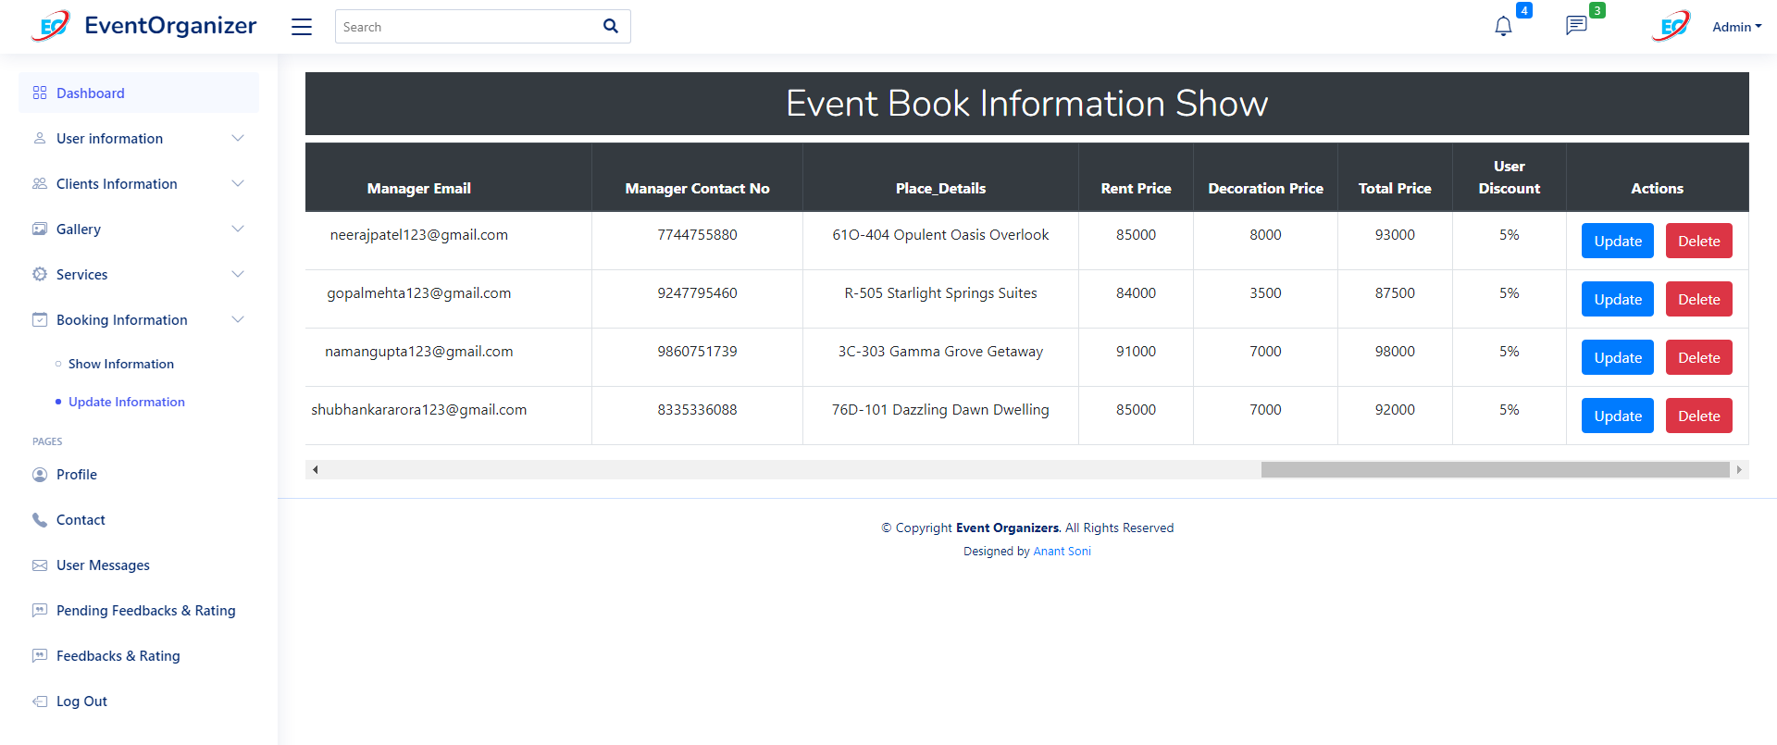

User-msg-info.php

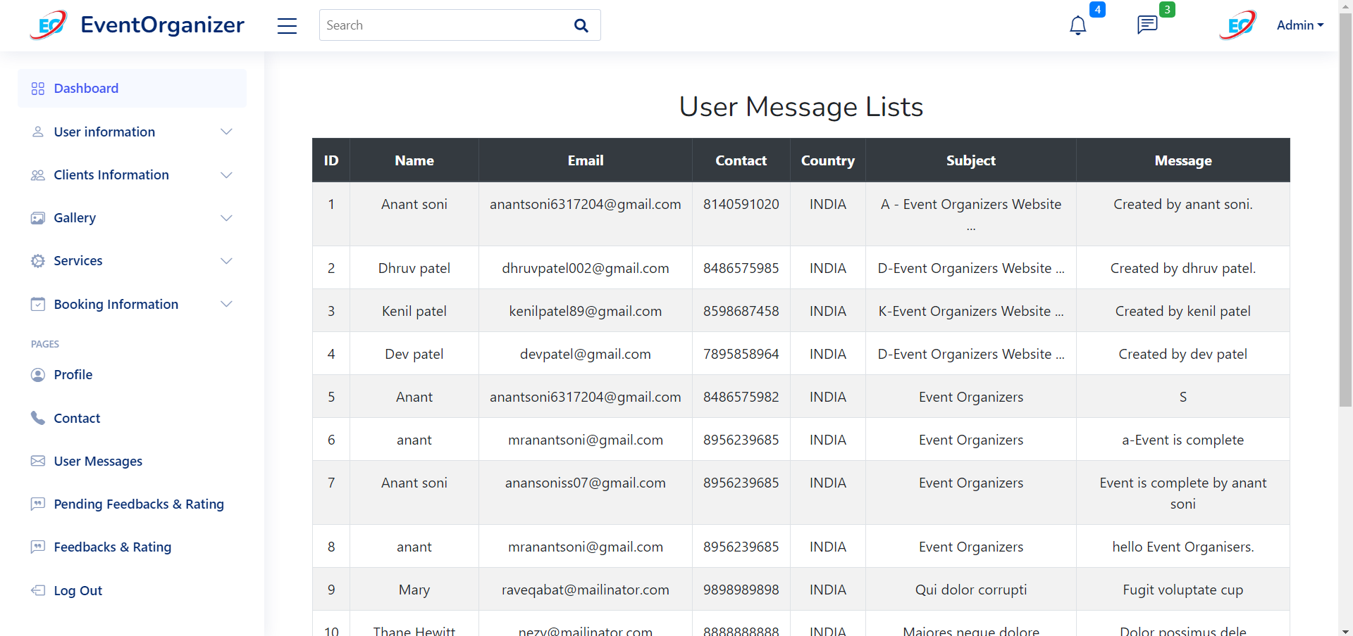

**6.4 Output Design**

User-login-data-update.php

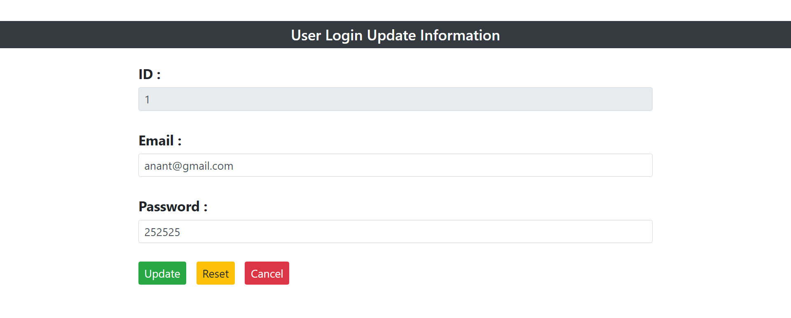

User-register-data-update.php

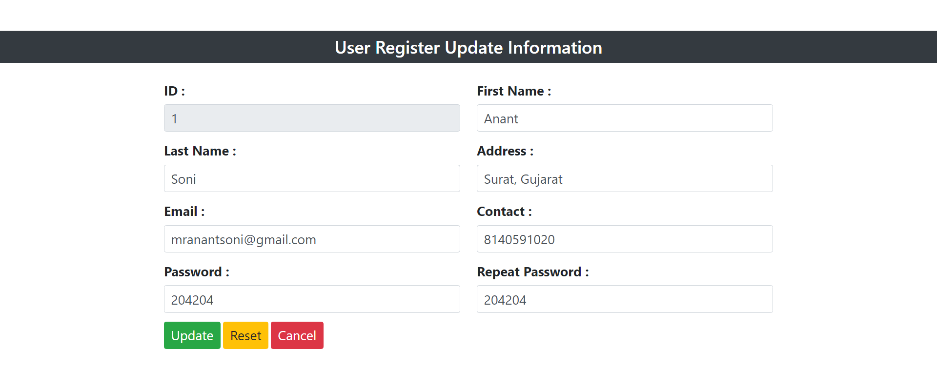

Client-gallery-data-update.php

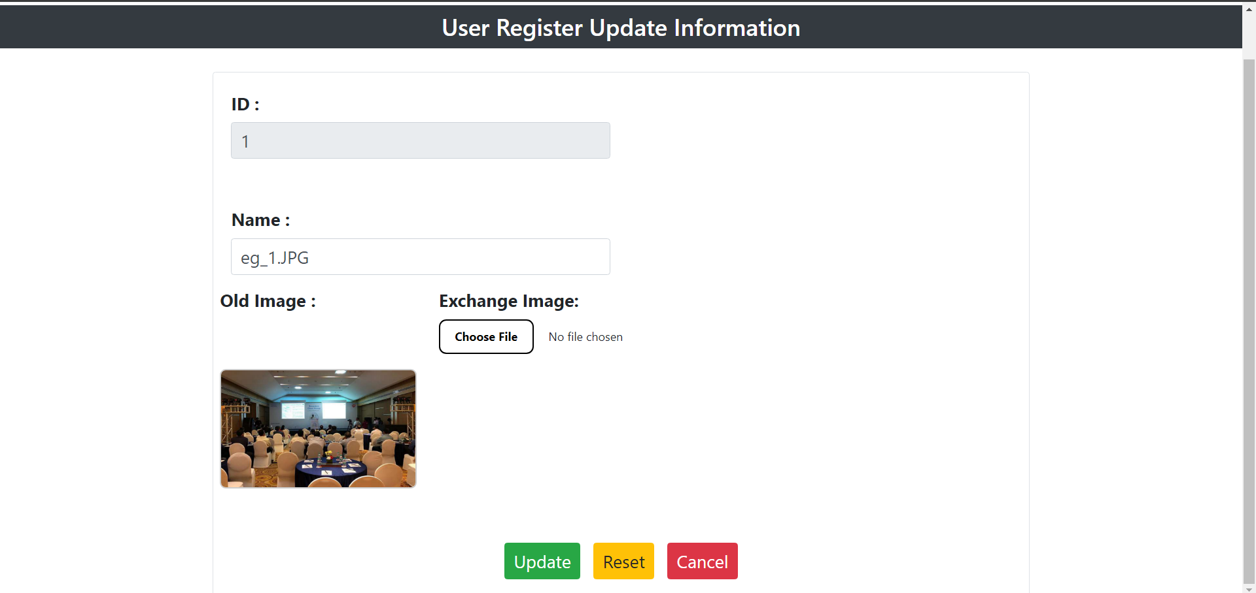

Client-service-data-update.php

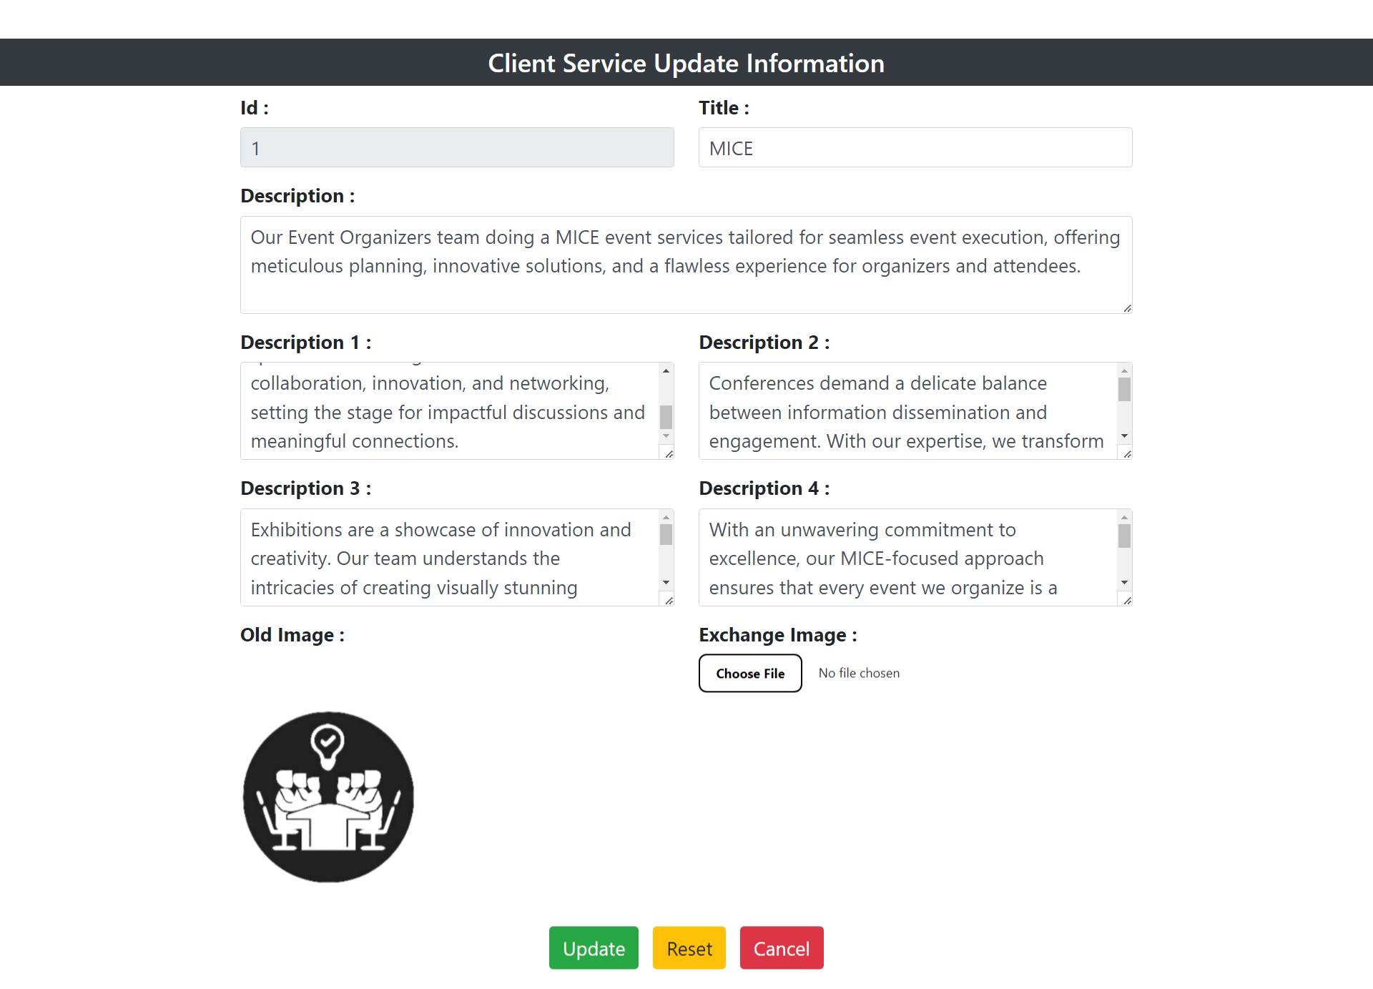

user-book-data-update.php

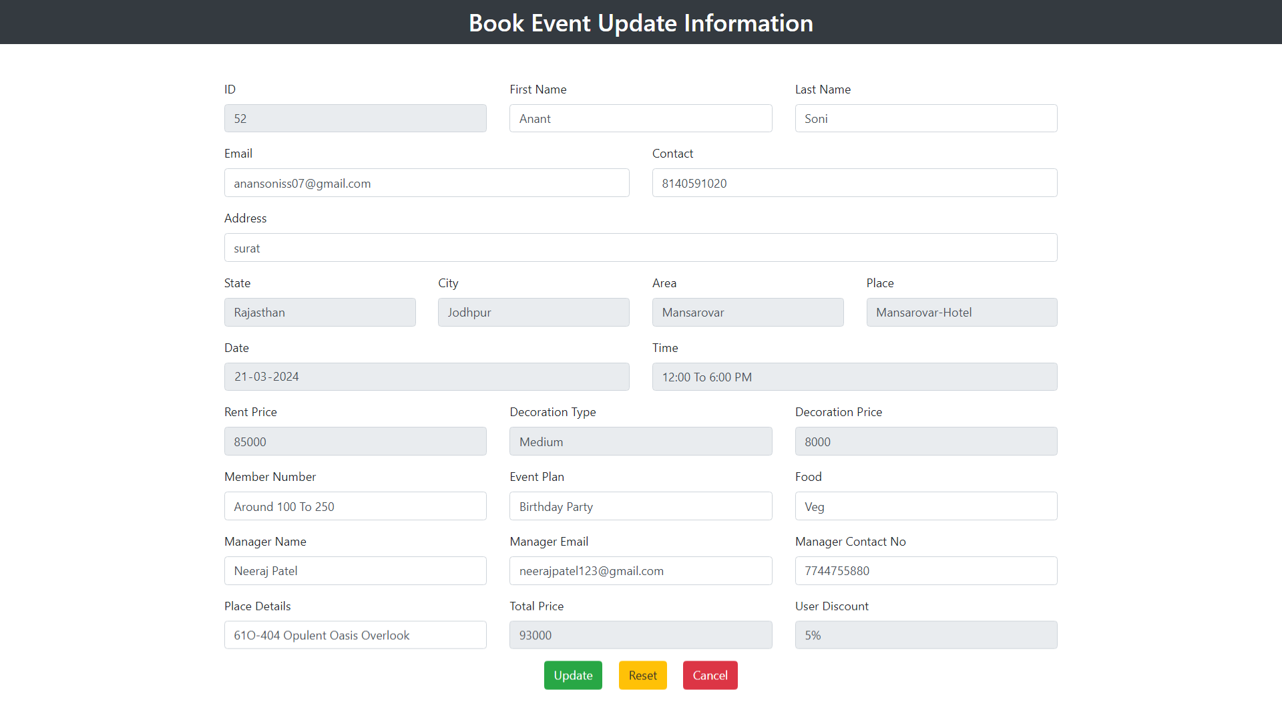

pending_fdbk_and_rtng.php

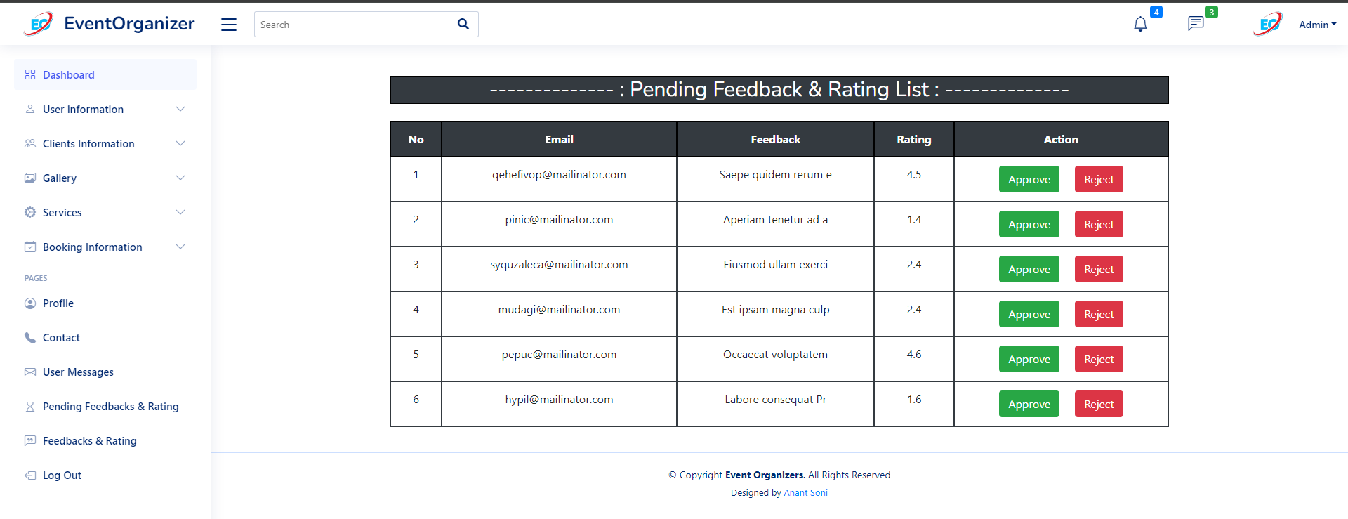

fdbk_and_rtng.php

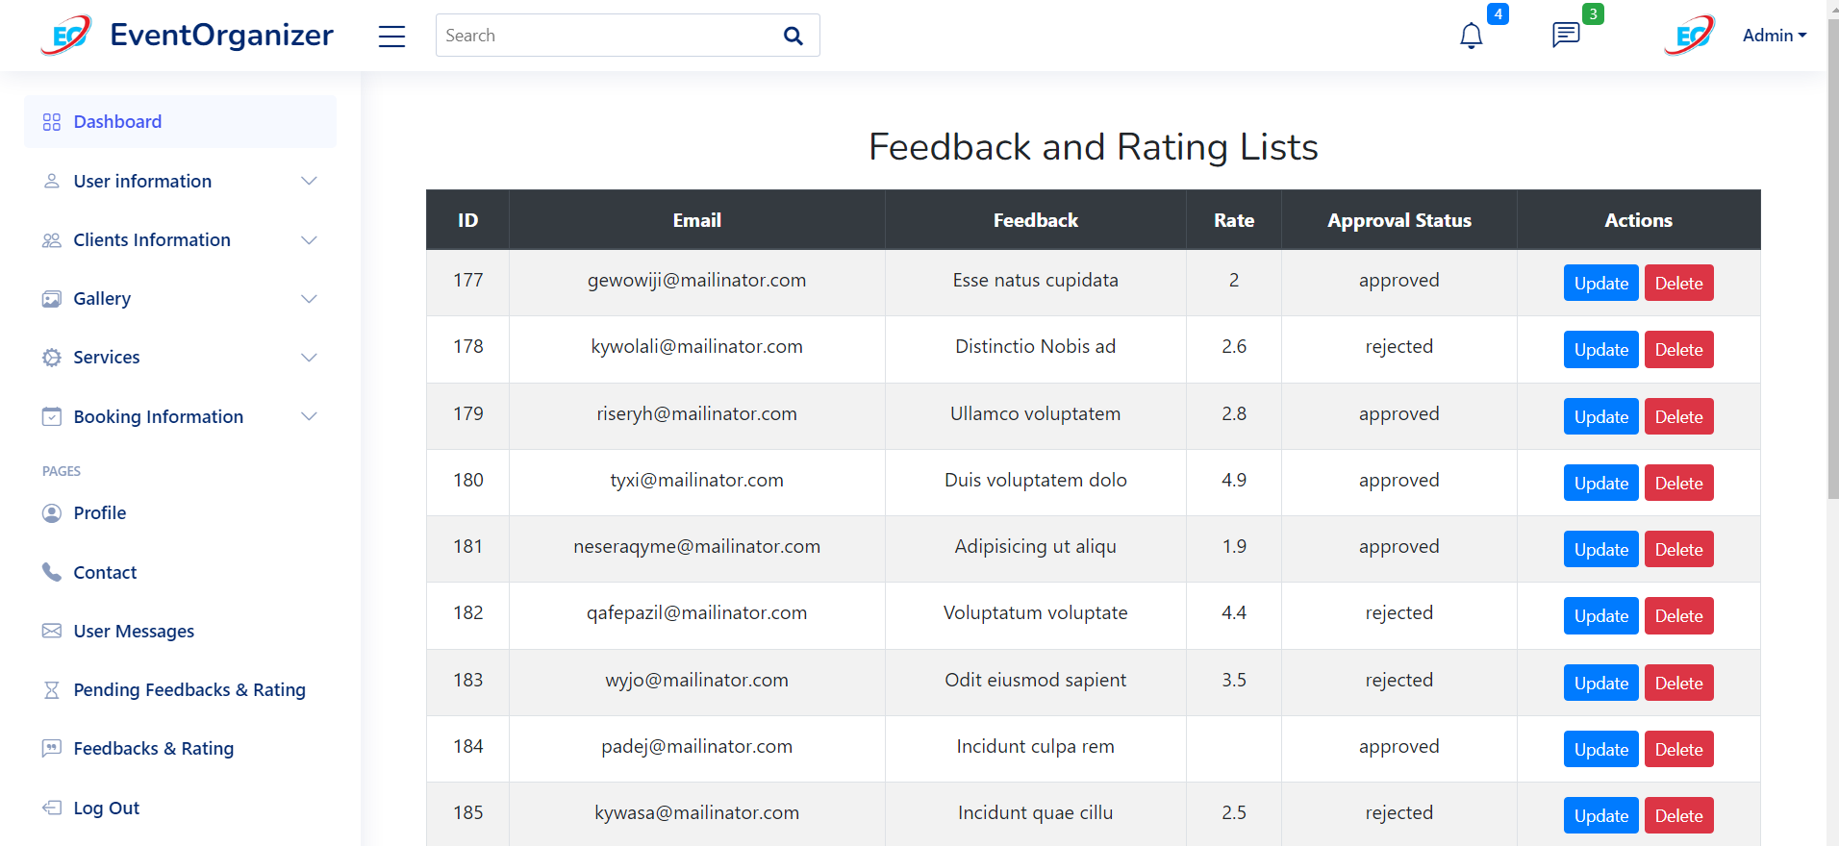

**7. Software Testing**

Software testing for the event organizers website involves a comprehensive evaluation of its functionalities, usability, security, and performance to ensure a seamless user experience and reliability. Testing encompasses various aspects such as event creation, venue selection, attendee registration, ticketing, and integration with third-party tools. Test cases are designed to validate different scenarios, including user interactions, error handling, data validation, and system response under load conditions.

Automation testing tools may be utilized to expedite testing processes and ensure consistency across multiple test runs. Security testing is essential to identify vulnerabilities and ensure the protection of sensitive user data and financial transactions. Usability testing involves gathering feedback from real users to assess the website's intuitiveness, navigation, and overall user satisfaction. Compatibility testing ensures the website functions correctly across different devices, browsers, and screen sizes.

Performance testing evaluates the website's response time, scalability, and stability under varying levels of user traffic and system load. Regression testing is conducted to verify that recent changes or updates do not introduce new issues or impact existing functionalities adversely. Defects and issues identified during testing are documented, prioritized, and addressed by the development team to ensure the website meets quality standards before deployment.

Incorporating automation testing tools into the testing process streamlines repetitive tasks and enhances overall efficiency. Security testing forms a critical component, identifying vulnerabilities and fortifying the website against potential threats to user data and financial transactions. Usability testing involves soliciting feedback from real users, enabling an assessment of the website's intuitiveness and user satisfaction, while compatibility testing ensures optimal performance across different devices and browsers.

Continuous testing practices are adopted to maintain the website's performance and reliability over time, with regular updates and improvements based on user feedback and evolving requirements. Embracing continuous testing practices, the website undergoes ongoing evaluation to maintain its performance and reliability over time. Regular updates and enhancements are driven by user feedback and evolving requirements, ensuring the website remains responsive and effective in meeting the needs of event organizers and attendees alike.

**Functional Testing :**

[A] User Registration and Authentication:

1. Verify that users can register with valid credentials.
2. Verify that users cannot register with invalid or duplicate email addresses.
3. Verify that users can log in with correct credentials.
4. Verify that users cannot log in with incorrect credentials.
5. Verify that users can reset their passwords.

[B] Event Creation and Management:

1. Verify that organizers can create new events with all required details.
2. Verify that organizers can edit existing events.
3. Verify that organizers can delete events.
4. Verify that events are displayed correctly in the organizer's dashboard.

[C] Attendee Management:

1. Verify that organizers can view a list of attendees for each event.
2. Verify that organizers can search for attendees by name or email.
3. Verify that organizers can update attendee information.
4. Verify that organizers can cancel attendee registrations.

[D] Invitation Sending and RSVP Tracking:

1. Verify that organizers can send invitations to potential attendees.
2. Verify that attendees can RSVP to invitations.
3. Verify that organizers can track RSVP responses in real-time.
4. Verify that organizers can send reminders to invited attendees.

[E] Payment Processing:

1. Verify that attendees can make payments for event registrations.
2. Verify that payment transactions are processed securely.
3. Verify that organizers can view payment status for each attendee.

[F] Reporting and Analytics:

1. Verify that organizers can generate reports on event attendance.
2. Verify that organizers can view analytics on registration trends.
3. Verify that reports and analytics data are accurate and up-to-date.

**Environment Testing :**

[A] Browser Compatibility Testing:

1. Test the web application on popular web browsers such as Google Chrome, Mozilla Firefox, Safari, Microsoft Edge, and Opera.
2. Verify compatibility with different versions of each browser.
3. Test on both desktop and mobile versions of browsers.

[B] Operating System Compatibility Testing:

1. Test the web application on different operating systems including Windows, macOS, Linux, Android, and iOS.
2. Verify compatibility with various versions of each operating system.

[C] Performance Testing:

1. Measure the application's response time, load time, and overall performance under different network conditions (high-speed, 3G, 4G).
2. Conduct stress testing to assess how the application handles heavy traffic loads.

[D] Device Compatibility Testing:

1. Test the web application on different devices including desktops, laptops, tablets, and smartphones.
2. Verify compatibility with various screen sizes and resolutions.

[E] Database Configuration Testing:

1. Test the application with different database configurations (MySQL, PostgreSQL, MongoDB, etc.).
2. Verify data integrity and consistency across different database setups.

[F] Third-Party Integration Testing:

1. Test integrations with third-party services such as payment gateways, social media APIs, etc.
2. Verify data exchange and functionality with external services.

[G] Security Testing:

1. Conduct security testing to identify and address vulnerabilities in each environment.
2. Ensure compliance with security standards and best practices.

**Usability Testing :**

1. Navigation Efficiency:

Assess how easily users can navigate through the website to find information about events, register, and purchase tickets. Evaluate the clarity of navigation menus, breadcrumbs, and search functionality.

1. Intuitiveness:

Determine if the layout and design of the website are intuitive for users, allowing them to quickly understand how to interact with different elements without requiring extensive instructions or guidance.

1. Consistency:

Ensure consistency in design elements, terminology, and layout across all pages of the website. Inconsistent design can confuse users and lead to a disjointed user experience.

1. Error Handling:

Evaluate how the website handles user errors, such as invalid form submissions or missing fields during registration. Clear and informative error messages should guide users on how to correct mistakes effectively.

1. Mobile Responsiveness:

Test the website's responsiveness on various mobile devices and screen sizes to ensure a seamless user experience for users accessing the site on smartphones and tablets.

1. Loading Speed:

Assess the loading speed of pages, images, and interactive elements on the website. Slow loading times can frustrate users and lead to high bounce rates.

1. Content Readability:

Verify that the content on the website, including event descriptions, schedules, and FAQs, is presented in a clear and readable format. Use appropriate font sizes, contrast ratios, and spacing to enhance readability.

1. User Feedback:

Gather feedback from users through surveys, interviews, or usability testing sessions to understand their experiences and identify areas for improvement. Pay attention to common pain points or suggestions for enhancing the user experience.

1. Accessibility:

Ensure the website is accessible to users with disabilities by testing features such as screen reader compatibility, keyboard navigation, and alternative text for images. Compliance with accessibility standards such as WCAG is essential for inclusive design.

1. User Satisfaction:

Measure user satisfaction with the website's usability through metrics such as task completion rates, time on task, and user satisfaction surveys. Positive user feedback indicates a successful usability testing process and a website that meets user needs effectively.

**7.1 Unit Testing**

Unit testing refers to the practice of testing certain functions and areas or units of our code. This gives us the ability to verify that our functions work as expected.

That is to say that for any function and given a set of inputs, we can determine if the function is returning the proper values and will gracefully handle failures during the course of execution should invalid input be provided.

Unit testing is a software testing method by which individual units of source code, sets of one or more computer program modules together with associated control data, usage procedures, and operating procedures, are tested to determine whether they are fit for use. Intuitively, one can view a unit as the smallest testable part of an application. In procedural programming, a unit could be an entire module, but it is more commonly an individual function or procedure.

Unit tests are short code fragments created by programmers or occasionally by white box testers during the development process. It forms the basis for component testing.

Ultimately, this helps us to identify failures in our algorithms and/or logic to help improve the quality of the code that composes a certain function.

As you begin to write more and more tests, you end up creating a suite of tests that you can run at any time during development to continually verify the quality of your work.

This website is tested by the following steps and prepared for the final implementation.

* To improve quality
* The website should be checked logically.
* For verification and validation.
* Validation and cross checks should be there.
* Avoiding a duplication of records, which cause redundancy of data.

|  |  |  |  |  |  |  |  |  |  |  |  |
| --- | --- | --- | --- | --- | --- | --- | --- | --- | --- | --- | --- |
| **Test Case No.** | **Field** | | **Input** | | **Actual Output** | | **Expected Output** | | **Pass/**  **Fail** | | **Remark** |
| 1. | Username | |  | | Please Provide user name | | Please Provide user name | | Fail | | Not allow Null Value |
| 2. | Username | | Anant1233 | | Enter Valid Name | | Enter valid name | | Fail | | Provide appropriate Name |
| 3 | Username | | Anant | | Accept | | Accept | | Pass | | allow |
| 4 | Create  Password | | Anant | | Enter valid password | | Enter valid password | | Fail | | Provide  one number |
| 4. | Create Password | | Anant123 | | Enter valid password | | Enter valid password | | Fail | | One capital latter necessary |
| 5. | Create Password | | Anant123 | | Accept | | Accept | | Pass | |  |
| 6 | Email-id | | Anant | | Enter valid email id | | Enter valid email id | | Fail | | Please provide proper format of email |
| 7 | Email-id | | Anant@ | | Enter valid email-id | | Enter valid email id | | Fail | | Please provide proper format of email |
| 8 | Email-id | | [Anant@gmail.com](mailto:ajay@gmail.com) | | Accept | | Accept | | Pass | |  |
| 9. | Mobile |  | | Please provide valid number | | Please provide valid number | | Fail | | Not Allow Null Value | |
| 10. | Mobile | 784848rtft | | Please provide valid number | | Please provide valid number | | Fail | | Character not allow | |
| 11. | Mobile | 78787878787878 | | Please provide valid number | | Please provide valid number | | Fail | | Not allow more than 10 number. | |
| 12. | Mobile | 8788787878 | | Accept | | Accept | | Pass | |  | |
| 13. | Gender |  | | Please choose proper Gender | | Please choose proper Gender | | Fail | | Not allow Null Value | |
| 14. | Gender | Male\female | | Accept | | Accept | | Pass | |  | |
| 15 | Security  Question |  | | Please select the question | | Please select the question | | Fail | | Not allow Null Value | |
| 16 | Security Question | Select question From Category | | Accept | | Accept | | Pass | |  | |
| 17 | Security Answer |  | | Please Write security answer | | Please provide security answer | | Fail | | Not allow Null Value | |
| 15. | Security Answer | Nickname | | Accept | | Accept | | Pass | |  | |
| 16. | Security Answer | ketan123 | | Accept | | Accept | | Pass | |  | |

|  |  |  |  |  |  |  |
| --- | --- | --- | --- | --- | --- | --- |
| **Test Case No.** | **Field** | **Input** | **Actual Output** | **Expected Output** | **Pass/Fail** | **Remark** |
| 1 | Email-id | Anant | Enter valid email id | Enter valid email id | Fail | Please provide proper format of email |
| 2. | Email-id | Anant@ | Enter valid email-id | Enter valid email id | Fail | Please provide proper format of email |
| 3. | Email-id | [Anant@gmail.com](mailto:ajay@gmail.com) | Accept | Accept | Pass |  |
| 4 | Create  Password | Anant | Enter valid password | Enter valid password | Fail | Provide  one number |
| 5. | Create Password | Anant123 | Enter valid password | Enter valid password | Fail | One capital latter necessary |
| 6. | Create Password | Anant123 | Accept | Accept | Pass |  |

|  |  |  |  |  |  |
| --- | --- | --- | --- | --- | --- |
| **Test Case No.** | **Input** | **Test Case Description** | **Expected Output** | **Actual Output** | **Remark** |
| 1. | Enter login credentials and click login button. | Check interface link between login and dashboard with proper information | To be redirected to dashboard | To be redirected to dashboard | Integration Testing Pass |
| 2. | Enter login credentials and click login button | Check interface link between login and dashboard with proper information | Error improper input | Error improper input | Integration Testing Fail |

**7.2 Integration Testing**

Navigation testing confirm that all internal and external links are working properly. There is no any broken link or orphan page in application.Functional, integration, system, regression, performance and load testings come under black box testings. Functional, integration testing is done in white box also.

For proper navigation in website, some points should be tested:

**1. Database Integration Testing:**

* Verify that data is correctly retrieved, stored, and updated in the database.
* Test database connectivity and transactions to ensure smooth interaction between the website and the database management system (DBMS).
* Validate data consistency across different database tables and entities.

**2. External System Integration Testing:**

* Test integration with external systems such as payment gateways, CRM (Customer Relationship Management) systems, email services, and social media platforms.
* Verify that data exchange and communication with external systems occur accurately and securely.
* Ensure proper error handling and logging for failed integration attempts.

**3. Third-Party API Integration Testing:**

* Test integration with third-party APIs (Application Programming Interfaces) used for services like maps, event ticketing, weather forecasts, and event management tools.
* Validate API requests and responses, including authentication, authorization, and data formatting.
* Check for proper error handling and fallback mechanisms in case of API failures or downtime.

**4. Module Integration Testing:**

* Verify interactions between different modules or components of the website, such as user authentication, event registration, ticket purchasing, and content management.
* Test data flow and communication between modules to ensure that information is passed accurately and efficiently.
* Validate cross-functional workflows, such as user registration followed by event booking and email notifications.

**5. User Interface (UI) Integration Testing:**

* Test the integration of UI components, including navigation menus, forms, buttons, and interactive elements.
* Validate UI consistency and responsiveness across different devices and screen sizes.
* Ensure that user inputs are processed correctly and feedback is provided promptly.

**6. End-to-End Integration Testing:**

* Conduct comprehensive end-to-end tests to simulate real-world user scenarios from start to finish.
* Verify complete user journeys, including browsing events, registering for events, purchasing tickets, and receiving confirmation emails.
* Identify and address any bottlenecks, performance issues, or integration failures that may arise during the entire process.

**7. Performance and Scalability Testing:**

* Evaluate the performance of integrated systems under different loads and concurrency levels.
* Test scalability by gradually increasing the number of simultaneous users, events, or transactions.
* Identify resource constraints, optimize system configurations, and implement caching mechanisms to enhance performance.

**7.3 System Testing**

System testing is a crucial phase in the software development lifecycle aimed at ensuring that the website functions as expected and meets the requirements of both the event organizers and the end-users. This document serves as a comprehensive guide to understanding the system testing process for your website, outlining its objectives, methodologies, and key considerations. It is the combination of hardware and software environment on which the tests will be executed. It includes hardware configuration, operating system settings, software configuration, test terminals and other support to perform the test.

1. Objectives of System Testing

2. Methodologies and Approaches

2.1 Functional Testing

2.2 Usability Testing

2.3 Compatibility Testing

2.4 Performance Testing

2.5 Security Testing

3. Key Considerations

**Example:**

A typical Environmental Configuration for a web-based application is given below:

OS-Windows/Linux

* **Processor**: Intel Core i5
* **RAM**: 8GB or 16GB of RAM
* **Operating System**: Windows 11
* **Browser**: IE/FireFox/Google Chrome
* **Web Server** : XAMPP
* **Database**: Mysql

**8. Limitations and Future Scope of Enhancements**

**Limitations :**

1. **Scalability:** The current architecture may face challenges in scaling up to accommodate a large influx of users during peak event registration periods. This could result in performance issues or system downtime.
2. **Limited Third-Party Integrations:** While the website integrates with some third-party tools for ticketing and payment processing, there may be limitations in integrating with a wider range of services or platforms, limiting flexibility for event organizers.
3. **Mobile Responsiveness:** Although efforts have been made to ensure mobile responsiveness, there may still be areas where the user experience on mobile devices is not optimized.
4. **Security Vulnerabilities:** Despite rigorous security testing, there is always a risk of undiscovered vulnerabilities that could compromise the security of user data or the integrity of the website.
5. **User Feedback Mechanisms:** The current system may lack robust mechanisms for gathering and incorporating user feedback, hindering the process of continuous improvement and refinement.
6. **Complexity for Non-Tech-Savvy Users**: Websites designed for event organization may require a certain level of technical expertise to navigate effectively. This can be a limitation for users who are less familiar with technology or who have accessibility needs.
7. **Limited Customization**: While many event organizers' websites offer templates and customization options, there may be limitations on how much you can customize the site's appearance and functionality. This can make it difficult to create a unique or tailored experience for your event attendees.
8. **Integration Issues**: Integrating with other systems such as payment gateways, marketing tools, or event management software can sometimes be challenging. This can lead to issues with data synchronization, reporting, and overall workflow efficiency.
9. **Security Concerns**: Event organizers' websites often handle sensitive information such as attendees' personal details and payment information. Ensuring the security of this data is crucial, and any vulnerabilities in the website's infrastructure could pose a risk to both attendees and the event organizer.
10. **Mobile Responsiveness**: With the increasing use of smartphones and tablets, it's essential for event organizers' websites to be optimized for mobile devices. However, some platforms may not offer robust mobile responsiveness, leading to a poor user experience for mobile users.
11. **Limited Support**: Depending on the platform or service provider, there may be limitations in terms of customer support. This can be frustrating for event organizers who encounter technical issues or need assistance with using the website effectively.
12. **Cost**: While many event organizers' websites offer tiered pricing plans to accommodate different budgets, the cost can still be a limiting factor for some organizers, particularly those organizing smaller or non-profit events.
13. **Dependency on Internet Connection**: Event organizers' websites typically rely on an internet connection to function properly. This can be a limitation in areas with poor internet connectivity or during events held in remote locations.
14. **Competition and Visibility**: With numerous event organizers' websites vying for attendees' attention, standing out from the competition and ensuring visibility can be challenging. This may require additional marketing efforts outside of the website itself.

**Future Scope of Enhancements:**

1. **Enhanced Scalability:** Implementing a more scalable architecture using cloud-based solutions or microservices can improve the website's ability to handle increased traffic during peak periods.
2. **Expanded Third-Party Integrations:** Integrating with additional third-party services such as event marketing platforms, CRM systems, or analytics tools can provide event organizers with more comprehensive functionality and insights.
3. **Improved Mobile Experience:** Investing in further optimization for mobile devices, including responsive design improvements and native app development, can enhance the user experience for mobile users.
4. **Advanced Security Measures:** Continuously monitoring and updating security protocols, conducting regular security audits, and implementing advanced encryption techniques can bolster the website's defenses against potential threats.
5. **Feedback Mechanisms:** Implementing features such as user surveys, feedback forms, or community forums can facilitate gathering user input and insights, guiding future development efforts and ensuring alignment with user needs and preferences.
6. **Personalization Features:** Introducing personalized recommendations, tailored content, or customizable event planning tools can enhance user engagement and satisfaction by delivering more relevant and personalized experiences.
7. **Social Integration:** Integrating with social media platforms for event promotion, registration, and engagement can amplify reach and facilitate viral marketing efforts for event organizers.
8. **Advanced Analytics:** Enhancing analytics capabilities to provide event organizers with deeper insights into attendee behavior, event performance metrics, and ROI can empower data-driven decision-making and optimization strategies.
9. **Personalization and Customization**: Implementing features that allow users to personalize their experience based on their preferences, such as preferred event types, locations, or performers. This could include personalized recommendations and notifications.
10. **Virtual Events Integration**: As virtual events become more prevalent, integrating features to host, promote, and manage virtual events seamlessly on the website can be valuable. This may include live streaming capabilities, virtual attendee interaction tools, and post-event content access.
11. **Enhanced Mobile Experience**: Optimizing the website for mobile devices to ensure a smooth and intuitive experience for users accessing the site on smartphones and tablets. This could involve implementing responsive design principles and mobile-specific features.
12. **Social Media Integration**: Integrating social media features to allow users to easily share events, RSVP, and engage with event content directly from the website. This can help increase event visibility and audience engagement.
13. **Advanced Ticketing and Registration Options**: Offering more flexibility and convenience in ticketing and registration processes, such as mobile ticketing, dynamic pricing, group discounts, and integration with popular payment gateways.
14. **Interactive Event Calendars**: Creating interactive event calendars that allow users to filter events by date, category, location, and other criteria. Incorporating features like event reminders, calendar syncing, and event discovery algorithms can enhance the user experience.
15. **Community Engagement Features**: Building community features such as forums, discussion boards, and user-generated content sections where attendees can interact, share experiences, and connect with each other before and after events.
16. **Accessibility Enhancements**: Ensuring that the website is accessible to users with disabilities by implementing features such as screen reader compatibility, keyboard navigation support, and text alternatives for non-text content.

**9. Bibliography & Reference**

**Bibliography :**

<https://www.omi.wa.gov.au/resources-and-statistics/publications/publication/event-management-planning-guide>

<https://www.omi.wa.gov.au/docs/librariesprovider2/project-planning-resources/event_management_guide_2020.pdf?sfvrsn=3f12f71_6>

<https://codedesign.co/top-10-event-planning-websites/>

<https://colorlib.com/wp/event-planner-websites/>

<https://www.v3events.in/>

**References :**

<https://youtu.be/LgMbITJUdM0?si=VrSjVj34Xf2PZqUG>

<https://youtu.be/jRq0NWlEw50?si=9ALL2ROOhNytb3Yl>

<https://youtu.be/SCi-BNgRIhY?si=CeFcnCQD9ETkxOT9>

<https://youtu.be/iEasMXu72No?si=fj5AlaMaeULzWl4B>

<https://youtu.be/r6JqSA2RQPE?si=HfNquSaw5CnYQ0os>